1.0 Executive Summary
Welcome to the future of event planning! Occasions, The Event Planning Specialists, brings to the community of Portland a new breath of air in the event planning market. By combining old fashioned values, going the extra mile, and using cutting edge event-planning software, Occasions will lead the market, providing the same quality results, every time.
Occasions is an equal opportunity business making its expertise and its products available to help its customers plan their own events. Party Packs (complete kits for their event), make hosting a party a snap, right down to the refreshments. The event planning software brings interactive event planning as close as their personal computer. Through these and other affordable products and services, Occasions aims to be the number one resource for any event.
Highlights
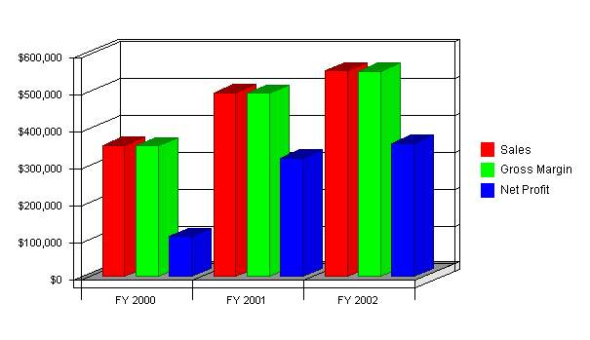
1.1 Objectives
Occasions is a small business aimed at the big time. In order to reach its lofty goals, Occasions must focus on the mission behind the vision. It will take all the employees, owners, founders, and vendors daily living the vision that Occasions represents. The vision manifests itself in three ways:
- Be one of the top three event planning specialists in the Northwestern United States.
- Justly compensate the employees, owners, and founders of Occasions.
- Produce the same quality results, every time.
1.2 Mission
In an ever changing, fast-paced world, success is determined by good choices for lasting effects. Communication is essential. Occasions strives to be the best choice of clients by helping to ease their event planning burden. Through consistent, predictable professionalism, Occasions will ensure a worry and hassle-free event at a reasonable price.
But, not all our clients will be external. Occasions has internal clients to serve. Occasions will strive to provide the same predictable and professional working environment to its employees and contracted vendors, justly compensating them for their services. It is also a priority to make a comfortable living wage for its owners, founders, full-time staff, and their families.
Keeping in tune with the needs of the market, utilizing the latest technology and trends, all while ensuring the client receives the individual attention they deserve, is the vision and daily mission of Occasions; The Event Planning Specialists.
1.3 Keys to Success
Our keys to success include the commitment to quality by every person who is part of the team. Each of us will be responsible to push ourselves to a higher level of professionalism in three areas:
- Consistent, accurate fulfillment of the client's wishes.
- Competitive pricing for the quality of services offered.
- Significant profit made on each event planned.
2.0 Company Summary
Founded in 1997 on a part-time basis, Occasions is a small business designed to meet the needs of the ever changing social world. Portland, Oregon is the current home with plans to expand to branch offices within four years. Occasions' staff of two, with numerous contract vendors, plans events, writes event-planning products, and trains area students in the art of event planning. Occasions is invested in the community it resides in.
Occasions is, in part, the answer to demands of the social world, on the working family, heavily-burdened office, out-of-town business, or special occasion in need of special recognition. As a business, we understand the needs of public and private organizations. As parents and family members, we understand the needs of setting special time apart from other events in our lives. Occasions strives to accomplish these goals, in Portland and eventually other areas of the Pacific Northwest.
2.1 Company Ownership
Occasions is established as a sole proprietorship with the intention of selling the business when it is established to one of the employees invested in the vision of event planning. All aspects of the business will be documented to ensure clients can count on the same results every time. It is these documents that will become the basis of ownership. The sole proprietor will use his or her name as the guarantor of each service. Therefore, the sole proprietor must embody the vision and mission of Occasions.
2.2 Start-up Summary
Through careful planning on the part of the founders, the start up costs for Occasions are minimal. It began as a home-based business with little overhead, and it continues to demand fewer outlay of funds as a service-based business. The start-up cost investment funds were assets saved from prior earnings by the owners who did event planning on a part-time basis before establishing themselves as a business.
It is the wish of the founders to remain a debt-free establishment. However, recognizing that in reality not all variables are controllable, outside financing is a viable option. Both founders own homes and have a perfect credit rating.
Start-up
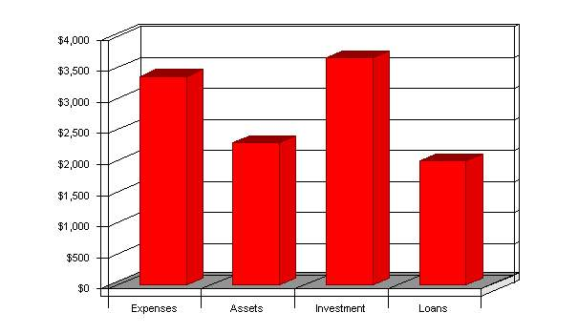
Start-up
Start-up
Requirements
Start-up Expenses
Legal | $200
Stationery etc. | $300
Brochures | $185
Consultants | $200
Insurance | $145
Rent | $150
Research and Development | $0
Expensed Equipment | $1,985
Other | $200
Total Start-up Expenses | $3,365
Start-up Assets Needed
Cash Balance on Starting Date | $2,300
Start-up Inventory | $0
Other Current Assets | $0
Total Current Assets | $2,300
Long-term Assets | $0
Total Assets | $2,300
Total Requirements | $5,665
Funding
Investment
Alicia Nollan | $3,400
Other | $265
Total Investment | $3,665
Current Liabilities
Accounts Payable | $0
Current Borrowing | $2,000
Other Current Liabilities | $0
Current Liabilities | $2,000
Long-term Liabilities | $0
Total Liabilities | $2,000
Loss at Start-up | ($3,365)
Total Capital | $300
Total Capital and Liabilities | $2,300
2.3 Company Locations and Facilities
Occasions is located inside the city limits of Portland, Oregon. It is a home-based business. Most meetings with clients are conducted in social settings, such as restaurants, coffee houses, the client's home, facilities wishing to be used for the event, or over the phone. Although the demand has not yet reached its peak, Occasions will eventually move from its home base into a small office complex, also within the city limits of Portland, Oregon. When the company has reached its finished point, Occasions will have branch offices in Portland, Eugene, and Bend, Oregon, Seattle, Vancouver, and Olympia, Washington, and Boise and Sun Valley, Idaho.
The company will maintain a high degree of professionalism. All offices are equipped with the latest in business technology, such as telephone systems, computers, fax machines, email, duplicators, printers, and software. Each location will have a secure storage area for supplies and equipment used in events, such as walkie-talkies, cellular phones, portable fax machines, and laptops.
3.0 Products and Services
Although Occasions is primarily a service business, we also offer products to aid our customers in planning the event themselves. The following products are tools used inside our operation for the best possible results:
- Party Pack
The Party Pack is a complete kit for any party. It includes decorations, lighting effects guide, disposable theme cameras, cutlery, plates, napkins, cups, punch mix (or recipe), snack supplies (or recipe), tablecloths, theme music (where applicable), invitations, thank-you cards, and a step-by-step guide to planning, putting together,and hosting the event.
- Step-by-Step Guides
These booklets include a calendar to map out the event, a step-by-step guide on what is needed for and how to put together a successful, worry-free event, resource information, popular refreshments with recipes, games, and tips to put their event in the record books. The events available include birthdays for all ages, meetings, retreats, parties, vacations, and special occasion celebrations such as graduations, holidays, showers, weddings, and receptions.
- Event Planning Software
Due to be released June 2000, this cutting-edge tool will allow the client all the resources and visual aids for their event planning. They will be able to play with decoration themes, listen to theme music, design invitations, thank-you cards, and RSVP cards, use the interactive planning calendar, and much more. This software will bring their event into the millennium with cutting edge technology that is designed to save time and money.
- Resources Manual
This valuable guide acts as a review for all the resources located in the surrounding area. A ranking is given to the various services, such as caterers, decorators, disc jockeys, bands, and facilities. This manual gives the client the freedom of making a choice based on experience.
Free Event Planners Training for High School and College Students
As a member of the Portland community, it is our mission to support our community. Ten hours each month will be devoted to training area students in event planning. This will aid them in planning proms, graduation parties, river clean-ups, homecoming, and other important events. This is a priority of Occasions. It will not be cut back as the business grows.
Occasions provides event planning in a wide range of applications. We guarantee satisfaction in the areas of appearance, performance, and taste. The following is a sampling of the types of events we plan every year:
- Meetings, Trainings, and Retreats.
- Conferences and Workshops.
- Birthdays, Anniversaries, Graduations and Holidays.
- Weddings, Receptions, and Showers.
- Company picnics, banquets, and award ceremonies.
.....and any other event that needs to be planned.
3.1 Competitive Comparison
Occasions, although young, draws from the age-old tradition of going above and beyond what is expected, every time. Our systems for event planning have been drawn up, evaluated, practiced, worked, and reworked to ensure the maximum efficiency while minimizing the possibility of error. We employ local vendors who have the same desire to be the best at what they do, while providing un-matchable services. Thus, we give back to the community by providing jobs outside of our organization. We encourage new and upcoming small businesses who provide a service within our need base to step up to the challenge of being the best through their contract with Occasions.
Our products will serve the function of aiding those that cannot afford the cost of an event planner. We wish to make our event planning tips available to those who need a helping hand. Occasions is a member of the community. Through event planning, Occasions gets the opportunity to laugh when the community laughs and cry when the community cries, to rejoice when the community rejoices and to help put the pieces back together when things change or begin to fall apart. We care about the things that have meaning in the lives of our neighbors.
4.0 Market Analysis Summary
The following sections describe the market segmentation, strategies, and industry analysis.
4.1 Market Segmentation
The breakdown of the market for event planning, falls in a wide, very diverse grouping. Individuals as well as organizations demand the services we provide. In order to provide the greatest depth of information, the market segments have been broken down into private and public organizations, and age groups.
- Private Organizations and Businesses
Private organizations make up the single largest portion of Occasions' client base. Private organizations such as businesses, corporations, and political parties host the most events on the largest scales, therefore, these events generate larger revenues per event. The majority of larger scale holiday functions will fall under this segment.
- Public Organizations
Government agencies host many events every year. Occasions hopes to alleviate the pressure of event planning for public employees. The second single largest segment, the public sector, can save money and give back to its community at the same time. These events are moderate in scale with middle to low revenues generated. Emphasis is placed on the visibility of the event for public viewing. The majority of organizational family functions will fall under this segment.
- Age Breakdowns
  - Under 24: Persons under the age of twenty-four (24) using an event planner are rare at best. We hope to tap the early college graduates who have begun their professional careers but have not yet started their families. These events will focus mainly on themes with moderate to high energy appeal. The revenues generated will range from moderate to high, depending on the event. The majority of weddings will fall into this segment.
  - Ages 25-55: The persons that fall into this age group are employed, middle to upper-middle class families. The reason they choose event planners is they are too busy to do it themselves. Therefore, Occasions will be on hand for questions, contact will be moderate in length but occur regularly so as not to disturb the daily life of the families. These events will generate moderate revenues, with a few generating low revenues. The majority of special occasion planning will occur in this market segment.
  - Ages 56 and above: Persons over the age of 55 have reached the turning point of life. Many are retiring, others are celebrating anniversaries of significant years, and still others are seeing that their children's special events are taken care of. These events will generate moderate to high revenues depending upon the income level of the family (direct correlation to social status). Most holiday parties, and other special occasions, such as wedding receptions and reunions, will occur in this market segment.
- Other
This segment has no direct information to compile for a description. It consists of any event planned that does not fit into one of the above categories.
Market Analysis (Pie)
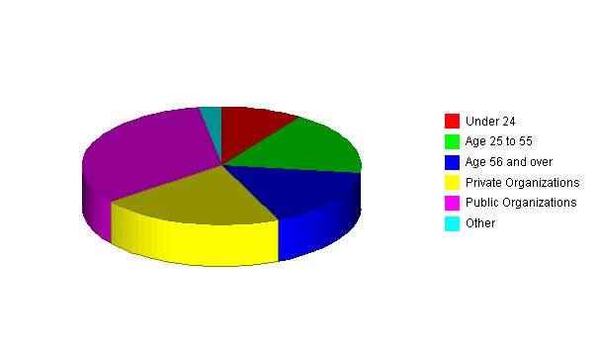
Market Analysis
Market Analysis
Potential Customers | Growth | 1999 | 2000 | 2001 | 2002 | 2003 | CAGR
Under 24 | 3% | 18 | 19 | 20 | 21 | 22 | 5.14%
Age 25 to 55 | 15% | 33 | 38 | 44 | 51 | 59 | 15.63%
Age 56 and over | 9% | 31 | 34 | 37 | 40 | 44 | 9.15%
Private Organizations | 60% | 40 | 64 | 102 | 163 | 261 | 59.83%
Public Organizations | 30% | 62 | 81 | 105 | 137 | 178 | 30.17%
Other | 10% | 5 | 6 | 7 | 8 | 9 | 15.83%
Total | 31.95% | 189 | 242 | 315 | 420 | 573 | 31.95%

4.2 Target Market Segment Strategy
Our target markets are middle to upper-middle class families, couples, individuals, or private and public organizations. We chose these groups because they are most able to afford event planners, and have the least amount of time to spare for event planning in general. Families demand attention, employees are overburdened, and overwhelming detail needed to plan large events are too large a constraint to place on people not trained in the area of event planning.
The fast pace of the world we live in leaves little time for extra things we would like to do, like plan events, parties, and social get-togethers. Occasions fills the need by being available to take on the burden of planning so that people can spend time on more important things, like family and friends. The demand for this service can only increase considering the rise in incomes, population, and need for interpersonal relations in the workplace.
4.3 Service Business Analysis
Occasions is in a unique position of competition. We compete against hotels with conference facilities, conference centers, other event planners both on the large and small scale, persons within an organization who are assigned the task of organizing an event, and people who wish to organize their own events without the benefit of assistance. The benefits and drawbacks of each of our competitors as compared with the services we offer are hardly a match in quality and price.
- Hotels and Conference Centers
Strengths: On-site facilities, equipment, and support staff. Ability to transport and house persons for overnight stays. Able to internalize costs of transportation and equipment.
Weakness: Often very expensive, impersonal, rely on unskilled labor for support staff. The error rate is high due to high volume and traffic from other events happening at the same time.
- Other Event Planners
Strengths: Have been in the market longer, have established a reputation and client base.
Weakness: Reputation precedes them, no systems-based businesses designed to produce consistent results; focus on smaller events, specialized events are main focused rather than all events; do not have the supporting products to market with, or instead of, event planning services.
- Employees or Persons wishing to do it themselves
Strengths: Internalized cost of planning the event; able to add tiny personalized touches that have meaning within the group or family.
Weakness: Consumes time that could be spent on other things; don't have access to the best prices, services, and other needed resources available.
5.0 Strategy and Implementation Summary
Marketing and Competition
We have discussed our client base as being predominately middle to upper-middle class individuals, couples or families, public and private organizations. We must then look at the needs of these markets and cater to them. We promise the same great results, every time.
When marketing to individuals, the idea of releasing them from the task, freeing their time for family and friends, and the promise of a worry-free event are the buzz words and concepts. Our marketing is predominantly by word of mouth or visual connection to large events these individuals have participated in or worked at.
When marketing to public or private organizations, the idea of greater efficiency for the money and a professional event without error would be the key concept. Groups, especially large ones, do not wish to deal with problems that arise due to oversight on their part. If the guarantee of worry-free, error-free events is available at a cost benefit to them, there really appears to be no better choice.
5.1 Sales Strategy
Occasions deals with a diverse market of clients. Within each market segment, closing of sales will differ. Each approach is described as follows:
- Private and Public Organizations
Sales will be concluded one to two days after the end of the event. A follow-up phone call will be placed informing the client of the total cost, number of attendees, and information about the billing packet that will arrive at their offices. Feedback forms will be included in these packets to ensure the client is being served as they deem appropriate. Form letter thank-yous will be sent following each event.
- Individuals
Sales will be concluded with a follow-up phone call one to two days after the event. The phone call will explain the total cost of the event, number of attendees, and information concerning the billing. Individual parties of any age group are placed on a billing cycle. Invoices will be sent out the 25th of the month and will be due the 10th of the following month. Feedback forms will be included in these packets to ensure the client is being served as they deem appropriate. Thank-you cards will follow each individual event.
5.1.1 Sales Forecast
By beginning on a smaller scale, Occasions has the foresight to grow at a rapid pace to keep up with demand. We wish to maintain a steady rate of sales growth; however, we understand that sales of products and services will vary in different months. As noted in the graph and chart, rapid increases during the holiday season will boost sales, then allow that growth to level off at a steady rate.
Sales Monthly
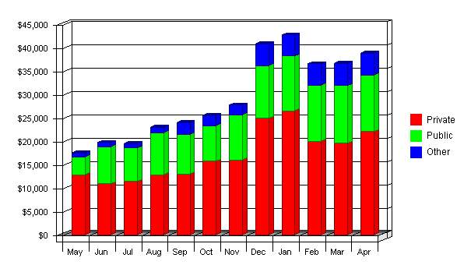
Sales Forecast
Sales Forecast
Sales | FY 2000 | FY 2001 | FY 2002
Private | $206,170 | $276,099 | $299,002
Public | $113,185 | $178,490 | $193,000
Other | $33,794 | $40,081 | $62,777
Total Sales | $353,149 | $494,670 | $554,779
Direct Cost of Sales | FY 2000 | FY 2001 | FY 2002
Private | $312 | $330 | $355
Public | $210 | $246 | $346
Other | $132 | $151 | $189
Subtotal Direct Cost of Sales | $654 | $727 | $890

6.0 Management Summary
Information and expense details are presented in subtopics Organizational Structure and Personnel Plan.
6.1 Organizational Structure
The management team within Occasions will be small in the beginning. The primary employee is the founder, who plans events, then contracts with caterers, decorators, disc jockeys, and bands to fill out the event. A contract labor site manager will be on hand to work the events as a liaison and vendor coordinator. Thus, there are two main employees with various levels of vendors.
When Occasions reaches its expansion goals, each office will have one to two event planners, an office assistant, two to three site managers for the events, and a product and marketing specialist. This team will function as one with constant communication through weekly staff meetings, email, and message boards. All jobs are interrelated. The performance of one effects the performance of the others; therefore, each team member expects nothing but the best from each other.
As it functions currently, we see no gaps in the management of this organization. Should Occasions grow beyond its estimated size, more positions in specialized areas will need to be added as well as additional site support and office assistance. To fill these positions, Occasions is looking for energetic, teachable, detail-oriented persons who want the potential to grow and improve their skills within the organization. Occasions wants to be the best; therefore, they will hire those who want to succeed.
6.2 Personnel Plan
The following table shows the estimated personnel needs for Occasions.
Personnel
Personnel Plan
 | FY 2000 | FY 2001 | FY 2002
Event Specialist | $36,000 | $40,000 | $42,000
Site Manager | $11,097 | $13,750 | $14,560
Other | $8,947 | $9,560 | $10,000
Total People | 7 | 8 | 9
Total Payroll | $56,044 | $63,310 | $66,560

7.0 Financial Plan
Service-based businesses require little funds to start up, and as they grow and expand, less funds to maintain. The charts and graphs that follow will show that investment up front allows Occasions to function debt-free with little overhead. This gives Occasions a quicker break-even point and increased profit margins from the start. As Occasions grows, the debt-free philosophy will be maintained until it is impossible to function during growth periods without financial assistance.
7.1 Important Assumptions
Tax rates are noted for information. We carry no loan burden that would be effected by these rates. What hits Occasions the hardest (but not nearly are bad as other service businesses), is the tax rate of 23.5%, which is nearly one quarter of the total sales. As Occasions continues to grow, these numbers will be reference rather than influence.
General Assumptions
General Assumptions
 | FY 2000 | FY 2001 | FY 2002
Plan Month | 1 | 2 | 3
Current Interest Rate | 8.92% | 8.92% | 8.92%
Long-term Interest Rate | 7.99% | 7.99% | 7.99%
Tax Rate | 24.04% | 23.50% | 24.04%
Sales on Credit % | 60.00% | 60.00% | 60.00%
Other | 0 | 0 | 0
7.2 Key Financial Indicators
The break-even point for Occasions is based on the assumption that we will produce 22 events per month and average approximately $521 per event. In the current situation, we average more than this assumption for our public and private organization events. These currently make up 18 of the 22 average events hosted per month.

Benchmarks
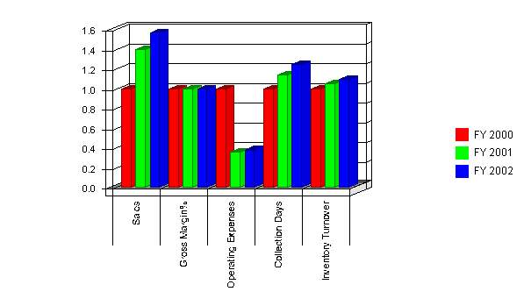
7.3 Break-even Analysis
The break-even point will appear more rapidly for Occasions than for other types of home-based businesses. Start-up costs are limited to minimal equipment, there is little or no staff to pay in the beginning, and contracted companies will handle any additional equipment required for the planned events.
Break-even Analysis
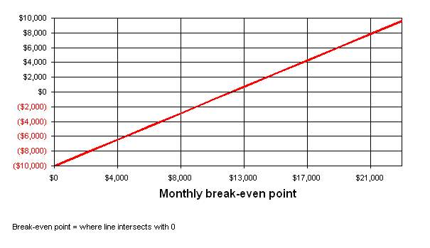
Break-even Analysis
Break-even Analysis:
Monthly Units Break-even | 22
Monthly Revenue Break-even | $11,682
Assumptions:
Average Per-Unit Revenue | $521.00
Average Per-Unit Variable Cost | $75.00
Estimated Monthly Fixed Cost | $10,000
7.4 Projected Profit and Loss
Leading the industry in event planning requires the use of the resources available at the lowest cost. As noted in the table, we spend less money on overhead than another event planners with an outside office or office space in their own facility. This savings allows us to market in creative ways and spend funds on expansion into other areas when the time is right.

Profit and Loss
Pro Forma Profit and Loss
 | FY 2000 | FY 2001 | FY 2002
Sales | $353,149 | $494,670 | $554,779
Direct Costs of Goods | $654 | $727 | $890
Other | $196 | $203 | $221
 | ------------ | ------------ | ------------
Cost of Goods Sold | $850 | $930 | $1,111
Gross Margin | $352,299 | $493,740 | $553,668
Gross Margin % | 99.76% | 99.81% | 99.80%
Expenses:
Payroll | $56,044 | $63,310 | $66,560
Sales and Marketing and Other Expenses | $146,013 | $5,700 | $6,119
Depreciation | $110 | $102 | $96
Leased Equipment | $0 | $0 | $0
Utilities | $516 | $0 | $0
Insurance | $258 | $0 | $0
Rent | $1,440 | $0 | $0
Payroll Taxes | $6,725 | $7,597 | $7,987
Other | $0 | $0 | $0
 | ------------ | ------------ | ------------
Total Operating Expenses | $211,106 | $76,709 | $80,762
Profit Before Interest and Taxes | $141,193 | $417,031 | $472,906
Interest Expense | $235 | $334 | $430
Taxes Incurred | $33,345 | $97,924 | $113,591
Net Profit | $107,614 | $318,773 | $358,885
Net Profit/Sales | 30.47% | 64.44% | 64.69%
7.5 Projected Cash Flow
Our cash situation is great. Although we begin with little extra cash, our increased growth allows us to make up for lost time. Our cash balance is always above the mark with the cash flow not too far behind. We have no negatives in our cash analysis.
Cash
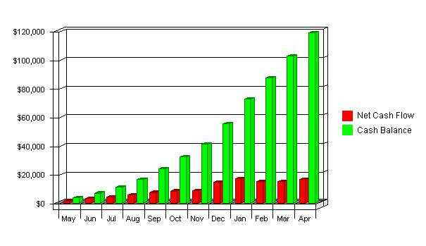

Cash Flow
Pro Forma Cash Flow
 | FY 2000 | FY 2001 | FY 2002
Cash Received
Cash from Operations:
Cash Sales | $141,260 | $197,868 | $221,912
Cash from Receivables | $187,091 | $286,864 | $328,647
Subtotal Cash from Operations | $328,351 | $484,732 | $550,558
Additional Cash Received
Sales Tax, VAT, HST/GST Received | $0 | $0 | $0
New Current Borrowing | $1,200 | $1,080 | $1,080
New Other Liabilities (interest-free) | $0 | $0 | $0
New Long-term Liabilities | $0 | $0 | $0
Sales of Other Current Assets | $0 | $0 | $0
Sales of Long-term Assets | $0 | $0 | $0
New Investment Received | $17,600 | $14,750 | $15,000
Subtotal Cash Received | $347,151 | $500,562 | $566,638
Expenditures | FY 2000 | FY 2001 | FY 2002
Expenditures from Operations:
Cash Spending | $23,731 | $13,637 | $15,433
Payment of Accounts Payable | $206,657 | $168,612 | $179,245
Subtotal Spent on Operations | $230,388 | $182,249 | $194,679
Additional Cash Spent
Sales Tax, VAT, HST/GST Paid Out | $0 | $0 | $0
Principal Repayment of Current Borrowing | $0 | $0 | $0
Other Liabilities Principal Repayment | $0 | $0 | $0
Long-term Liabilities Principal Repayment | $0 | $0 | $0
Purchase Other Current Assets | $0 | $0 | $0
Purchase Long-term Assets | $0 | $0 | $0
Dividends | $0 | $0 | $0
Subtotal Cash Spent | $230,388 | $182,249 | $194,679
Net Cash Flow | $116,763 | $318,313 | $371,959
Cash Balance | $119,063 | $437,376 | $809,335
7.6 Projected Balance Sheet
Occasions is set up for success. According to the numbers, we start out fair and end up amazing. By FY2000, we will be worth over $125,000 with a profit margin of over 30%. We are operating with little to zero debt, boosting the net worth even higher. Our only weakness is the products to be released in FY2000 have not been accounted for as an investment of funds. This will effect the cash flow in a moderate way, and is undetermined how it will effect the profit ratio of the business.

Balance Sheet
Pro Forma Balance Sheet
Assets
Current Assets | FY 2000 | FY 2001 | FY 2002
Cash | $119,063 | $437,376 | $809,335
Accounts Receivable | $24,798 | $34,736 | $38,956
Inventory | $109 | $121 | $148
Other Current Assets | $0 | $0 | $0
Total Current Assets | $143,970 | $472,233 | $848,440
Long-term Assets
Long-term Assets | $0 | $0 | $0
Accumulated Depreciation | $110 | $212 | $308
Total Long-term Assets | ($110) | ($212) | ($308)
Total Assets | $143,860 | $472,021 | $848,132
Liabilities and Capital
Current Liabilities | FY 2000 | FY 2001 | FY 2002
Accounts Payable | $15,146 | $8,704 | $9,850
Current Borrowing | $3,200 | $4,280 | $5,360
Other Current Liabilities | $0 | $0 | $0
Subtotal Current Liabilities | $18,346 | $12,984 | $15,210
Long-term Liabilities | $0 | $0 | $0
Total Liabilities | $18,346 | $12,984 | $15,210
Paid-in Capital | $21,265 | $36,015 | $51,015
Retained Earnings | ($3,365) | $104,249 | $423,022
Earnings | $107,614 | $318,773 | $358,885
Total Capital | $125,514 | $459,037 | $832,922
Total Liabilities and Capital | $143,860 | $472,021 | $848,132
Net Worth | $125,514 | $459,037 | $832,922
7.7 Business Ratios
Data on our business ratios is shown in the table below. Industry Profile ratios are based on Standard Industry Classification (SIC) Index code 7299.

Ratios
Ratio Analysis
 | FY 2000 | FY 2001 | FY 2002 | Industry Profile
Sales Growth | 0.00% | 40.07% | 12.15% | 17.90%
Percent of Total Assets
Accounts Receivable | 17.24% | 7.36% | 4.59% | 11.10%
Inventory | 0.08% | 0.03% | 0.02% | 4.60%
Other Current Assets | 0.00% | 0.00% | 0.00% | 37.10%
Total Current Assets | 100.08% | 100.04% | 100.04% | 52.80%
Long-term Assets | -0.08% | -0.04% | -0.04% | 47.20%
Total Assets | 100.00% | 100.00% | 100.00% | 100.00%
Current Liabilities | 12.75% | 2.75% | 1.79% | 33.90%
Long-term Liabilities | 0.00% | 0.00% | 0.00% | 28.00%
Total Liabilities | 12.75% | 2.75% | 1.79% | 61.90%
Net Worth | 87.25% | 97.25% | 98.21% | 38.10%
Percent of Sales
Sales | 100.00% | 100.00% | 100.00% | 100.00%
Gross Margin | 99.76% | 99.81% | 99.80% | 0.00%
Selling, General & Administrative Expenses | 69.22% | 35.37% | 34.65% | 72.70%
Advertising Expenses | 0.51% | 0.44% | 0.47% | 2.20%
Profit Before Interest and Taxes | 39.98% | 84.30% | 85.24% | 4.00%
Main Ratios
Current | 7.85 | 36.37 | 55.78 | 1.81
Quick | 7.84 | 36.36 | 55.77 | 1.33
Total Debt to Total Assets | 12.75% | 2.75% | 1.79% | 61.90%
Pre-tax Return on Net Worth | 112.31% | 90.78% | 56.73% | 6.30%
Pre-tax Return on Assets | 97.98% | 88.28% | 55.71% | 16.60%
Additional Ratios | FY 2000 | FY 2001 | FY 2002
Net Profit Margin | 30.47% | 64.44% | 64.69% | n.a
Return on Equity | 85.74% | 69.44% | 43.09% | n.a
Activity Ratios
Accounts Receivable Turnover | 8.54 | 8.54 | 8.54 | n.a
Collection Days | 32 | 37 | 40 | n.a
Inventory Turnover | 6.00 | 6.32 | 6.60 | n.a
Accounts Payable Turnover | 14.64 | 18.63 | 18.31 | n.a
Payment Days | 19 | 27 | 19 | n.a
Total Asset Turnover | 2.45 | 1.05 | 0.65 | n.a
Debt Ratios
Debt to Net Worth | 0.15 | 0.03 | 0.02 | n.a
Current Liab. to Liab. | 1.00 | 1.00 | 1.00 | n.a
Liquidity Ratios
Net Working Capital | $125,624 | $459,249 | $833,230 | n.a
Interest Coverage | 601.85 | 1250.06 | 1099.92 | n.a
Additional Ratios
Assets to Sales | 0.41 | 0.95 | 1.53 | n.a
Current Debt/Total Assets | 13% | 3% | 2% | n.a
Acid Test | 6.49 | 33.69 | 53.21 | n.a
Sales/Net Worth | 2.81 | 1.08 | 0.67 | n.a
Dividend Payout | 0.00 | 0.00 | 0.00 | n.a

