1.0 Executive Summary | [back to top]
StructureAll Ltd. will be formed as a consulting firm specializing in structural engineering services. A home office in Yellowknife, NT will be established the first year of operations to reduce start up costs. The founder of the firm is a professional engineer with eighteen years of progressive and responsible experience.
Initial start up costs amount to $20,000. Of this total, $13,000 is required for start up expenses while the balance is to to be placed in the company accounts as working capital. The founder, Philip Nolan, provided an initial investment of $20,000 towards start-up costs.
Projected sales and profits for the first three years of operation are summarized below:
Year | Sales($) | Profits($) | Sales/Profit(%)
1 | 118,000 | 9,150 | 7.8
2 | 130,000 | 12,650 | 9.8
3 | 138,000 | 15,100 | 11.0

The firm will specialize in providing three dimensional modeling and visualization to our clients. State-of-the-art analysis and design tools will be an integral part of the business plan. Implementation of a quality control and assurance program will provide a focus for production work.
Highlights
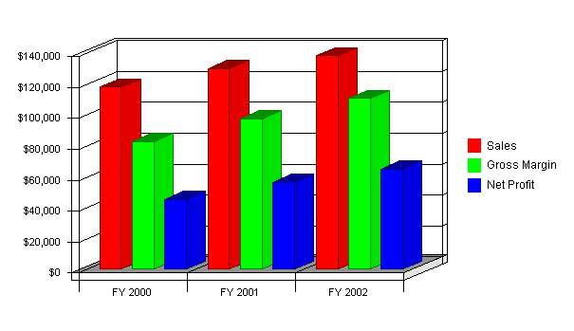
Click to Enlarge
1.1 Objectives | [back to top]
- Revenues of $118,000 the first year, approaching $138,000 at the end of three years.
- Achieve 20% of market value at the end of the third year of operation.
- Increase gross margin to 80% by the third year of operations.
1.2 Mission | [back to top]
Our mission is to provide clients across Canada's North with structural engineering services for all types of buildings, from concept planning through to completion, with a highly skilled professional team working together, using common sense and practical experience.
1.3 Keys to Success | [back to top]
- Provide professional quality services on time and on budget.
- Develop a follow-up strategy to gauge performance with all clients.
- Implement and maintain a quality control and assurance policy.
2.0 Company Summary | [back to top]
StructureAll Ltd. is a new company which provides professional engineering design services for clients which manage, maintain, and plan for residential, commercial, and industrial type buildings. Our focus will be the public sector market in remote communities across Canada's North.
2.1 Company Ownership | [back to top]
StructureAll Ltd. will be created as a limited liability company. The company will be privately owned by Philip D. Nolan. Leslie C. Goit will also be listed as a Director.
2.2 Start-up Summary | [back to top]
Our start-up expenses amount to $13,000, which allows for initial legal expenses, licenses, permits, stationary, specialty software, office equipment, and furniture. In addition to these start-up costs, an initial balance of $7,000 will be placed in the company accounts. The software purchases include an allowance of $5,000 for AutoCADD® 2000, $1,800 for National Master Specifications, and $200 for Quickbooks® (accounting package).
Philip Nolan will contribute $20,000 towards the overall start-up costs
Start-up
Requirements
Start-up Expenses
Professional Liability Insurance | $1,200
Web Site Development | $600
Legal Services | $500
Business Licenses | $1,000
Permit Holder ( NAPEGG ) | $500
Software Purchases | $7,000
Stationery | $600
Office Furniture | $600
Office Equipment | $500
Other | $500
Total Start-up Expenses | $13,000
Start-up Assets Needed
Cash Balance on Starting Date | $7,000
Other Current Assets | $0
Total Current Assets | $7,000
Long-term Assets | $0
Total Assets | $7,000
Total Requirements | $20,000
Funding
Investment
Philip D. Nolan | $20,000
Investor 2 | $0
Total Investment | $20,000
Current Liabilities
Accounts Payable | $0
Current Borrowing | $0
Other Current Liabilities | $0
Current Liabilities | $0
Long-term Liabilities | $0
Total Liabilities | $0
Loss at Start-up | ($13,000)
Total Capital | $7,000
Total Capital and Liabilities | $7,000
Start-up
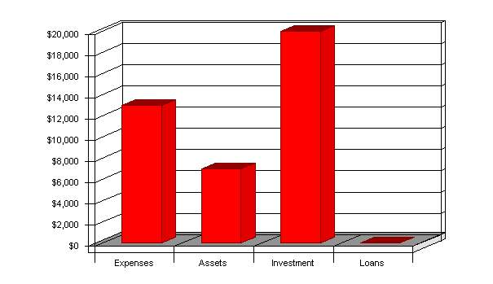
Click to Enlarge
2.3 Company Locations and Facilities | [back to top]
We will establish a home office in Yellowknife, NT in order to reduce start-up costs. The office space is estimated to be 150 square feet. We will be installing a dedicated fax line as well as a high-speed Internet connection. An interactive website will also be developed which will serve as a marketing tool. The domain name of "structureall.com" has already been reserved.
3.0 Services | [back to top]
StructureAll Ltd. offers complete structural engineering services. We will focus on buildings with the following 'Use and Occupancies':
- Residential.
- Commercial.
- Industrial.
The company is 'project' oriented where each project involves:
- Renovations.
- Rehabilitation.
- Additions.
- New construction.
We offer innovative and economical design services, maintaining state-of-the-art design technology. We meet client needs on projects of all sizes and smaller, special design projects.
3.1 Service Description | [back to top]
Project Consulting: Proposed and billed on a per-project and per-milestone basis, project consulting offers a client company a way to harness our specific qualities and use our expertise to develop and/or implement plans, from conceptual planning to turnover. Proposal costs will be associated with each project.
Forensic Investigations: Proposed and billed on a per-project and per-milestone basis, our investigations will serve the public and private sector markets. We will focus on troubleshooting buildings where damage and or failure has occurred. Our reports will outline the description of the problem, the nature of the mechanism which has caused damage or failure, and a list of options for remedial action including estimated budget costs for implementation.
Project Management: Our project management services include defining client needs, preparing bid documents, tendering, bid analysis, construction review, payment certification, contract administration, and warranty inspections. Projects include new facilities, renovations, repairs, and remodeling.
Dispute Resolution: We draw upon our broad range of construction and contract administration experience to provide dispute resolution services, including arbitration, mediation and expert reports for litigation. This work is supported by forensic engineering services to identify the cause of failures.
Restoration Engineering: We provide condition survey, design, and construction review services for the repair of building structures.
Home Inspections: We will provide prospective homeowners with an assessment of the various systems in a residential home, including foundations, framing, building envelope and efficiency, mechanical systems, electrical systems, and general safety issues. We provide a photographic record along with a thorough written report.
3.2 Competitive Comparison | [back to top]
StructureAll Ltd. offers their clients superior service accompanied with state-of-the-art analysis and design capabilities. We will offer three-dimensional visualization services to reduce the possibility of spatial conflicts with architectural elements and other engineering disciplines. In comparison, our competitors rely mostly on two-dimensional models.
We will implement a quality assurance and control program for all projects undertaken. This document will serve to focus on the standards which will be achieved and a means of measuring performance.
A systematic manner of sorting and retrieving a library of structural elements and assemblies will be implemented. Slide libraries will be available from a tool bar within AutoCADD for quick access. We will adopt the layering standards of the American Institute of Architects (AIA). In comparison, our competitors do not have an integrated database.
StructureAll Ltd. will adopt the filing systems developed by the AIA. All project information will be tracked using an integrated database management system. All of our business tools will be year 2000 compliant.
3.3 Sales Literature | [back to top]
A brochure system, which covers a broad spectrum of the target market segment will be developed during the initial year of operations. This system will be modular in nature and include many 'boiler plate' sections which may be edited to suit specific needs. Brochure inserts will be maintained as individual sheets to facilitate their assembly in any custom situation.
Our website will be developed the first year of operations and include a description of our services, the areas which we plan to serve, contact information, a list of representative projects, and a brief biography of Philip D. Nolan. An Internet domain name has already been reserved for this purpose ... http://www.structureall.com
A series of templates will be developed for project proposals. The format for all proposals will include:
- Cover letter.
- Scope of services for each project.
- Fee (if requested).
- Firm's qualifications to provide services (overview).
- Project Team (describes each person's tasks and qualifications).
- Philosophy of design approach.
- Relevant experience.
- Schedule to provide services.
3.4 Fulfillment | [back to top]
We will turn to qualified professionals to supplement computer aided design and drafting (CADD) services, specialty connection designs, and analysis support services which are areas that we can afford to contract out without risking the core values provided to the clients.
We have fostered several alliances with suppliers of structural elements, including glued laminated lumber, pre-engineered dimension lumber trusses, engineered lumber, and steel to facilitate this strategy.
In the second year of operations, we intend to secure a storefront presence in Yellowknife. At this stage, we will seek qualified northern engineering students to provide them with work experience in a structural engineering office environment.
3.5 Technology | [back to top]
StructureAll Ltd. will maintain complete and comprehensive Windows® based analysis tools for structural design. An integrated computer aided design and drafting tool permits several evaluations to be made on a structure at minimal cost.
StructureAll Ltd. will maintain an Internet website complete with file transfer protocol (ftp) capabilities.
3.6 Future Services | [back to top]
Quality Control and Assurance: Serving the needs of the welding industry, we will ensure that certified firms and their employee welders are qualified to perform specific welds in accordance with the requirements of the Canadian Welding Bureau (CWB) as a certified Welding Inspector. We are currently in the process of completing a comprehensive home study program offered through the CWB for this purpose.
There are four firms presently in the NWT which require these services in order to maintain their certification with the CWB. On-site inspections are required four times per year.
Fabrication and Detailing Drawings: Serving the special needs of steel and concrete construction, StructureAll Ltd. will be working toward offering these services to contractors in the future.
Toll-Free Communications: We will provide our clients a toll-free number to access 24 hours a day in the second year of operations.
4.0 Market Analysis Summary | [back to top]
StructureAll Ltd. will focus on traditional Architect/Engineering (A/E) contracts. The owner will usually contract the A/E to perform planning and design services. These design services include preparation of plans, specifications, and estimates.
Construction services may be limited to occasional field visits and certain contract administration requirements. Typically, these types of projects distribute total design fees amongst the professionals involved in accordance with the following guideline:
- Architecture Design (65%).
- Structural Design (10%).
- Mechanical Design (15%).
- Electrical Design (10%).
Our most important clients will be established architectural/engineering firms who require structural engineering services.
4.1 Market Segmentation | [back to top]
The market for engineering services may be summarized with the following groups:
- Established Architectural and Engineering firms: Typically, the structural portions of any building project involve a Prime Consultant who pre-selects their team members and promotes their strengths in a proposal call to prospective clients. Our strategy is to offer these established firms a viable resource from which to draw upon. We can undertake the entire structural engineering process or provide assistance to their own in-house staff.
- Territorial and Federal Governmental Departments: The Government of the Northwest Territories (GNWT) and the newly created Nunavut Territory retain consultants for a variety of purposes. We intend to position ourselves as a local firm offering expertise in consulting, project management, forensic, and restoration engineering. The Federal Government also retains consultants for similar purposes.
- Law Firms: We will market our services to the legal community to provide dispute resolution services, including arbitration, mediation and expert reports for litigation. This work is supported by forensic engineering services to identify the cause of failures.
- Contractors: We will offer design/build services to contractors for the multitude of potential projects which the Territorial Government and Nunavut Territory have recently undertaken. Contractors occasionally require structural engineers to submit sealed alternatives for equivalents to construction details.
- Municipal Governments: Remote Municipal Governments in the Territories can expect to have more autonomy with respect to infrastructure growth and development in the years to come. This initiative is part of the GNWT mandate. We will promote our services to the local municipal governments for this purpose. To attract this market potential, we will offer to train those students in each community who are interested in engineering as a career choice. On the local front, the City of Yellowknife often provides recommendations to builders and homeowners for structural engineering services related to renovations, additions, and new construction.
- Private Individuals: We will focus attention on homeowners in Yellowknife who are renovating or contemplating an addition to their residence. We will also promote home inspections to those parties contemplating the purchase of a home.
- Realtors: In conjunction with home inspections, we will make all the Realtors aware of this service.
The Potential Market Chart and the Market Analysis Table are based on percentages which each of these groups could contribute to the services offered. This manner of describing the potential market is more appropriate for this type of business. As can be seen, the Established Architectural/Engineering firms account for 65% of the potential market with the other participants claiming the balance in smaller proportions.
Market Analysis
Potential Customers | Growth | 1999 | 2000 | 2001 | 2002 | 2003 | CAGR
Architectural/Engineering Firms | 0% | 65 | 65 | 65 | 65 | 65 | 0.00%
Territorial/Federal Governments | 0% | 10 | 10 | 10 | 10 | 10 | 0.00%
Law Firms | 0% | 5 | 5 | 5 | 5 | 5 | 0.00%
Contractors | 0% | 5 | 5 | 5 | 5 | 5 | 0.00%
Municipal Governments | 0% | 5 | 5 | 5 | 5 | 5 | 0.00%
Private Individuals | 0% | 5 | 5 | 5 | 5 | 5 | 0.00%
Realtors | 0% | 5 | 5 | 5 | 5 | 5 | 0.00%
Total | 0.00% | 100 | 100 | 100 | 100 | 100 | 0.00%
Market Analysis (Pie)
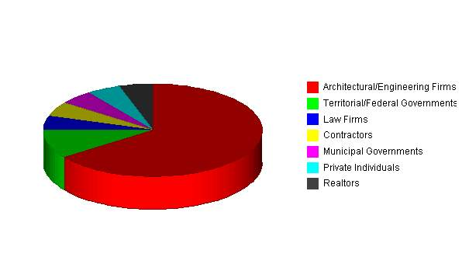
Click to Enlarge
4.2 Service Business Analysis | [back to top]
The following sections describe in more detail these aspects of the service business environment:
- Business Participants.
- Competition and Buying Patterns.
- Main Competitors.
4.2.1 Business Participants | [back to top]
The majority of consulting services cater to the needs of the Territorial Governments. The Territorial Governments operate on a budget of approximately $1,170 million per year, based on the 1998/1999 Main Estimates. Of this total, approximately $1,028 million is spent on Operating and Maintenance Expenditures while $142 million is allocated to Capital Expenditures.
Within the Capital Expenditures, Buildings and Works is a sub-category. This is the area of the annual operating budget from which all building design consultants must draw upon. Our analysis of the 1998/1999 Main Estimates indicates a total expenditure of $59,339,000. A typical A/E contract derives fee estimates from total budgets. For this analysis, we will apply 9% as a guideline for design fees. This yields a figure of about $5,340,000 in design fees available for distribution to the consulting industry.
The major clients within the Territorial Governments include:
- Department of Education.
- Department of Transportation.
- Department of Municipal and Community Affairs.
Our competition matrix indicates a total of 102 persons within the consulting field in the Territories. This total has been subdivided into the types of positions these people hold. Based on reasonable estimates of salary expectations including 30% burdens for administration yields a value of about $7,800,000. This figure represents an estimate of the revenues required to sustain engineering consultants in the Territories.
From this evaluation, the Territorial Governments account for close to 70% of design fees while other participants in the building marketplace account for the balance. The Territorial Governments retain consultants for the following types of buildings:
- Schools.
- Health Centres.
- Community Halls.
- Arenas.
- Warehouses.
- Firehalls.
These types of buildings are constructed on a rotating basis across several communities in the NT. In addition to new construction, rehabilitation, renovations, and additions are also in demand.
Typically, the Territorial Governments issue a proposal call to consultants to service these needs. StructureAll will position itself as a Structural Sub-Consultant or resource to the Prime Consultant.
StructureAll Ltd. will also promote its services as structural specialists and project managers to the Territorial Governments.
4.2.2 Competition and Buying Patterns | [back to top]
Pricing of projects and billing rates are surprisingly variable. In consulting at this level, it is easier to be priced too low than too high. Clients and potential clients expect to pay substantial fees for the best quality professional advice. The nature of the billing, however, is sensitive. Clients are much more likely to be offended when a job starts at $20K and ends up at $30K because of overruns, than if the same job started at $30K or even $35K.
Clients rarely compare consultants directly, looking for two, or more, possible providers of a proposed project or job. Usually they follow word-of-mouth recommendations and either go for the job or not, rather than selecting from a menu of possible providers.
The most important element of general competition, by far, is what it takes to keep clients for repeat business. It is worth making huge concessions in any single project to maintain a client relationship that brings the client back for future projects.
4.2.3 Main Competitors | [back to top]
- Ferguson Simek Clark (FSC Group): This well established architectural and multi-discipline engineering firm would be our main competitor. This firm has branch offices in Iqaluit, NT and Whitehorse, YT besides a head office located in Yellowknife, NT. Their principal strength is undertaking a project from inception through to completion under one roof. Their weakness stems from an understaffed structural engineering group. At present, there is only one structural engineer who services the needs of all their in-house architects and outside clients. The drafting aspects of any project rely upon recollection and modification of past projects typically. There is no systematic manner in which standard block libraries are maintained or updated. They underutilize the programs at their disposal for structural analysis and design.
- A.D. Williams Engineering Ltd. (ADWEL): This multi-discipline engineering firm is well established in Yellowknife. Their head office is located in Edmonton, Alberta. They can draw on additional resources from the core group as required to meet the demands of project schedules. At present, there is no resident structural engineer on staff in Yellowknife.
- Girvan and Associates: This is a small one person architectural and engineering firm which specializes in providing services for residential construction projects. Ian Girvan services the private sector mostly. It is our hope that we can form a strategic alliance to carry out consulting work jointly as needs and occasions arise.
5.0 Strategy and Implementation Summary | [back to top]
StructureAll Ltd. will focus on the Western Arctic area initially. We believe the creation of Nunavut will still provide opportunities for structural engineering services; however a separate Association of Professional Engineers for Nunavut is anticipated.
We are also licensed to practice in the Yukon Territories, although we have not planned for any aggressive marketing in this area.
The target client is usually an Architect Manager.
5.1 Competitive Edge | [back to top]
StructureAll Ltd. offers the following competitive edge:
- State-of-the-art modeling, design, analysis, and drafting capabilities.
- Quality control and assurance program.
- An Internet website (http:\\www.structureall.com, and e-mail, info@structureall.com).
5.2 Marketing Strategy | [back to top]
The sections which follow describe in more detail our positioning statement, pricing, and promotion strategy.
5.2.1 Positioning Statement | [back to top]
For established engineering and architectural firms in Yellowknife who require structural engineering sub-consultant services, StructureAll Ltd. offers a competitive and economical option. Projects may be delegated to StructureAll Ltd. directly or arrangements can be made to supplement and assist their own in-house staff.
5.2.2 Pricing Strategy | [back to top]
Most consulting work is billed on an hourly basis to pre-determined levels dictated by project schedule milestones. We have assigned a rate of $80/hour for basic consulting services and $40/hour for drafting services. These are conservative values for the consulting market. We have used conservative unit rates to remain more competitive.
5.2.3 Promotion Strategy | [back to top]
We will be using the Internet extensively in our sales promotion. Together with a well targeted direct mail and e-mail campaign, we will make all the major players in the marketplace aware of our presence.
We will focus our limited advertising budgets to promote community sponsored events. We will also offer technical services at discount rates to non-profit organizations.
When travelling to remote communities, we will contact the local principals in elementary and high schools offering them a speaker on structural engineering as a career choice.
StructureAll Ltd. will apply for the Northwest Territories Business Incentive Policy. This policy is directed at those firms resident in the Northwest Territories and provides incentives with respect to evaluation of services.
5.3 Sales Strategy | [back to top]
Success in a consulting market is focused on client service and typically translates into repeat business. We will avoid the pitfall of buying a project, only to find the scope of work far exceeds renumeration.
When a potential client questions the cost of a project, we explain the benefits and refer to our proposal which clearly outlines the tasks to be performed. If the budget is for less money, then we must offer less service.
Billing rates are not negotiated. One exception to this rule would be for not-for-profit organizations where marketing can be traded for services in kind.
5.3.1 Sales Forecast | [back to top]
The following table and chart summarizes forecasted sales. We expect sales to remain at a constant level after three months of operation. We predict the first two months of operations will be slow. Revenues will be limited while a generic quality management plan is formulated and basic office administration tasks are completed.
Direct unit costs for the first year have been set at 30% of unit revenues, which yields a 70% gross margin. In the third year of operations, we plan to increase gross margin to 80% as a result of providing a more efficient service to our clients.
Our unit rate for basic consulting services has been set at $80/hour. This is a conservative assumption based on published salary guideline levels for engineering professionals. Our unit rate for CADD services is $40/hr.
Sales Forecast
Unit Sales | FY 2000 | FY 2001 | FY 2002
Project Consulting | 690 | 750 | 800
Project Management | 240 | 260 | 280
Home Inspections | 96 | 110 | 120
Computer Aided Drafting Services | 890 | 1,000 | 1,050
Total Unit Sales | 1,916 | 2,120 | 2,250
Unit Prices | FY 2000 | FY 2001 | FY 2002
Project Consulting | $80.00 | $80.00 | $80.00
Project Management | $80.00 | $80.00 | $80.00
Home Inspections | $80.00 | $80.00 | $80.00
Computer Aided Drafting Services | $40.00 | $40.00 | $40.00
Sales
Project Consulting | $55,200 | $60,000 | $64,000
Project Management | $19,200 | $20,800 | $22,400
Home Inspections | $7,680 | $8,800 | $9,600
Computer Aided Drafting Services | $35,600 | $40,000 | $42,000
Total Sales | $117,680 | $129,600 | $138,000
Direct Unit Costs | FY 2000 | FY 2001 | FY 2002
Project Consulting | $24.00 | $20.00 | $16.00
Project Management | $24.00 | $20.00 | $16.00
Home Inspections | $24.00 | $20.00 | $16.00
Computer Aided Drafting Services | $12.00 | $10.00 | $8.00
Direct Cost of Sales | FY 2000 | FY 2001 | FY 2002
Project Consulting | $16,560 | $15,000 | $12,800
Project Management | $5,760 | $5,200 | $4,480
Home Inspections | $2,304 | $2,200 | $1,920
Computer Aided Drafting Services | $10,680 | $10,000 | $8,400
Subtotal Direct Cost of Sales | $35,304 | $32,400 | $27,600
Sales Monthly
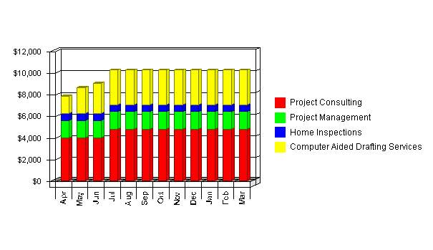
Click to Enlarge
5.4 Milestones | [back to top]
The accompanying table lists important program milestones, with dates and managers in charge, and budgets for each. The milestone schedule indicates our emphasis on planning for implementation.
What the table doesn't show is the commitment behind it. Our business plan includes complete provisions for plan-vs.-actual analysis, which will be updated monthly to compare the variance and plan for course corrections.
Milestones
Milestone | Start Date | End Date | Budget | Manager | Department
Complete Incorporation | 4/1/1999 | 4/15/1999 | $500 | PN | Administrative
Acquire Tradename for Internet Website | 3/6/1999 | 3/6/1999 | $400 | PN | Administrative
Submit Business License Application to City | 4/1/1999 | 4/16/1999 | $250 | PN | Administrative
Acquire WCB Coverage | 4/1/1999 | 4/16/1999 | $50 | PN | Administrative
Apply for Staad-Pro Core Financing | 4/1/1999 | 4/16/1999 | $0 | PN | Administrative
Acquire E&O Insurance | 4/1/1999 | 4/16/1999 | $1,200 | PN | Administrative
Other | 1/1/1999 | 1/1/1999 | $0 | ABC | Department
Totals |  |  | $2,400

6.0 Management Summary | [back to top]
StructureAll Ltd. will initially have one employee who is also acting as general manager. Phil Nolan will be responsible for all daily operations in the firm.
6.1 Management Team | [back to top]
Philip Nolan, P. Eng. has eighteen years of progressive and responsible engineering experience. Phil will be responsible for soliciting clients, marketing, promotion, and all daily aspects of running the business. He graduated from McGill University in Montreal, Quebec in 1981 with a Bachelor of Engineering degree.
Following graduation in 1981, Phil worked for consulting engineers in Toronto, Ontario on a variety of transportation planning projects.
In 1982, Phil moved to Yellowknife where he worked for the GNWT as a Project Engineer. Phil gained experience working on a host of community development and transportation related projects, including Little Buffalo River Bridge, Bridge Inspections, and Bridge Rehabilitations. Phil was with the GNWT for six years.
From 1988 to 1991, Phil worked for Foundation Co. of Canada Ltd., a large multi-national contracting firm as a project engineer where he gained experience in the use of explosives at the Magpie River Hydro Development and continued gaining experience on several bridge projects.
In 1992, Phil worked for Reid Crowther & Partners Ltd. out of Edmonton, Alberta on a host of bridge design and rehabilitation projects, including the Whitemud Ravine Pedestrian Bridges.
From 1993 to 1995, Phil was self employed as a private consultant offering services in quality control and assurance for building construction where he gained considerable experience in Preserved Wood Foundations and their use in residential and commercial applications.
In May of 1995, Phil joined the Ferguson Simek Clark (FSC) team of professionals and was responsible for all structural design, including quality control and assurance services for schools, arenas, health centres, and other buildings.
Phil will be the principal designer of all projects at StructureAll Ltd. Phil is currently working on a contract basis for Ferguson Simek Clark.
6.2 Management Team Gaps | [back to top]
StructureAll Ltd. will require administrative support to ensure clients are billed on a timely basis. We will be looking to an outside source for ensuring the books are kept in order and up to date.
Self sufficiency in computer aided drafting capabilities will require Phil to become more familiar with AutoCADD 2000 as a drafting tool. We will invest in continuing education to fulfill this need. We have accounted for this in the business plan.
6.3 Personnel Plan | [back to top]
The following table summarizes our personnel expenditures for the first three years, with compensation increasing from $50K the first year to $70K in the third. The detailed monthly personnel plan for the first year is included in the appendices.
Personnel Plan
 | FY 2000 | FY 2001 | FY 2002
Name or title | $0 | $0 | $0
Other | $0 | $0 | $0
Total People | 0 | 0 | 0
Total Payroll | $0 | $0 | $0

7.0 Financial Plan | [back to top]
The financial plan which follows summarizes information regarding the following items:
- Important Assumptions.
- Key Financial Indicators.
- Break-Even Analysis.
- Projected Profit and Loss.
- Projected Cash Flow.
- Projected Balance Sheet.
- Business Ratios.
7.1 Important Assumptions | [back to top]
The financial plan depends on important assumptions, most of which are shown in the following table as annual assumptions. The monthly assumptions are included in the appendices.
Some of the more important underlying assumptions are:
- We assume a strong economy, without major recession.
- We assume the creation of Nunavut will not dramatically change the delivery of engineering services.
- Interest rates, tax rates, and personnel burdens are based on conservative assumptions.
General Assumptions
 | FY 2000 | FY 2001 | FY 2002
Plan Month | 1 | 2 | 3
Current Interest Rate | 10.00% | 10.00% | 10.00%
Long-term Interest Rate | 10.00% | 10.00% | 10.00%
Tax Rate | 16.25% | 15.00% | 16.25%
Sales on Credit % | 100.00% | 100.00% | 100.00%
Other | 0 | 0 | 0

7.2 Key Financial Indicators | [back to top]
The following benchmark chart indicates our key financial indicators for the first three years. We foresee modest growth in sales and a marginal reduction in operating expenses for the years presented.
Benchmarks
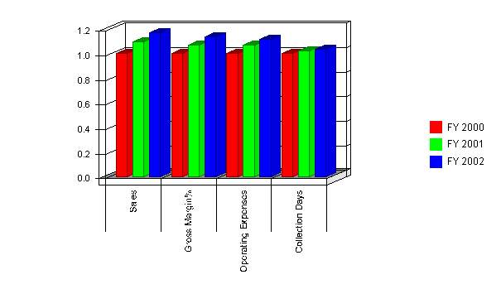
Click to Enlarge
7.3 Break-even Analysis | [back to top]
The following table and chart summarize our break-even analysis. With estimated monthly fixed costs of $6,500, billing targets of $10,000 per month will cover our costs. We don't really expect to reach break-even until a few months into the business operation.
The break-even assumes unit variable costs at 30 percent of unit revenue. The unit revenue value of $60/hour is an aggregate measure for all the types of services which will be offered.
Break-even Analysis
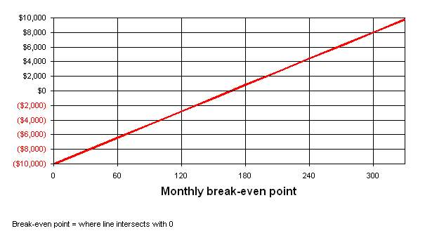
Click to Enlarge
Break-even Analysis:
Monthly Units Break-even | 167
Monthly Revenue Break-even | $10,000
Assumptions:
Average Per-Unit Revenue | $60.00
Average Per-Unit Variable Cost | $0.00
Estimated Monthly Fixed Cost | $10,000

7.4 Projected Profit and Loss | [back to top]
The gross margin for a service-based business is a reflection of the efficiency at which those services are offered. In the initial year of operations, we have targeted a gross margin of 70%. This is not an unreasonable figure for a consulting business. For the second and third year of operations, we have targeted gross margins of 75% and 80% to indicate overall improved efficiency at service delivery. Net Profit/Sales is determined to be 7.8% the first year, increasing to 9.8% the second year and 11.0% the third year. In order to fulfill the requirements of the mission statement and simultaneously reduce start up costs, we have made arrangements to purchase software on quarterly repayment options:
- Staad-Pro Core is a structural engineering design and drafting suite offered through Research Engineers Ltd. This program fulfills the need to carry out three-dimensional analysis and design requirements and is a key feature of the business plan. This program supports Canadian codes and standards. We have contacted the authorized Canadian reseller (Detech Corporation Ltd.) and will made arrangements to purchase this tool on four payments of $1,550 over the first year of operations.
- Errors and Omissions Insurance is required for all consultants working on behalf of the Territorial Governments. Through Falconair Insurance, we have received a quotation of $1,200/year for this coverage. The first year's premium payments are included in the start-up costs, with subsequent years indicated at the same annual premium.
- Website hosting fees are included as quarterly payments to Internic.com, the Web host. As part of this service, we will have at our disposal file transfer protocol capabilities. This feature permits us to place electronic media on the Internet for our clients and strategic allies.
Pro Forma Profit and Loss
 | FY 2000 | FY 2001 | FY 2002
Sales | $117,680 | $129,600 | $138,000
Direct Cost of Sales | $35,304 | $32,400 | $27,600
Other | $0 | $0 | $0
 | ------------ | ------------ | ------------
Total Cost of Sales | $35,304 | $32,400 | $27,600
Gross Margin | $82,376 | $97,200 | $110,400
Gross Margin % | 70.00% | 75.00% | 80.00%
Expenses:
Payroll | $0 | $0 | $0
Sales and Marketing and Other Expenses | $9,450 | $9,750 | $9,750
Depreciation | $1,800 | $1,800 | $1,800
WebSite Hosting Fees | $380 | $380 | $380
Telephone/Fax | $2,400 | $2,400 | $2,400
Software Purchases ( Staad-Pro Core) | $6,200 | $300 | $300
Utilities | $1,200 | $1,200 | $1,200
Errors and Omissions Insurance | $0 | $1,200 | $1,200
Rent | $0 | $4,800 | $4,800
Payroll Taxes | $7,500 | $9,000 | $10,500
Other | $0 | $0 | $0
 | ------------ | ------------ | ------------
Total Operating Expenses | $28,930 | $30,830 | $32,330
Profit Before Interest and Taxes | $53,446 | $66,370 | $78,070
Interest Expense | $179 | $495 | $830
Taxes Incurred | $8,319 | $9,881 | $12,552
Net Profit | $44,949 | $55,994 | $64,689
Net Profit/Sales | 38.20% | 43.21% | 46.88%

7.5 Projected Cash Flow | [back to top]
Cash flow projections are critical to our success. The monthly cash flow is shown in the illustration, with one bar representing the cash flow per month, and the other the monthly balance. The first few months are critical. It may be necessary to inject additional capital in this time-frame if the need arises. The annual cash flow figures are included here and the more important detailed monthly numbers are included in the appendices.
Cash
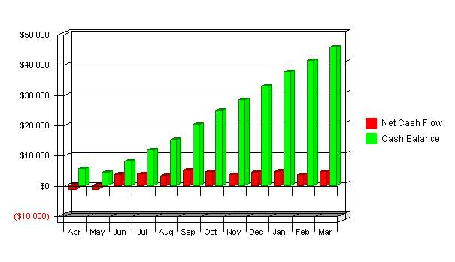
Click to Enlarge
Pro Forma Cash Flow
 | FY 2000 | FY 2001 | FY 2002
Cash Received
Cash from Operations:
Cash Sales | $0 | $0 | $0
Cash from Receivables | $102,661 | $128,079 | $136,928
Subtotal Cash from Operations | $102,661 | $128,079 | $136,928
Additional Cash Received
Sales Tax, VAT, HST/GST Received | $0 | $0 | $0
New Current Borrowing | $0 | $0 | $0
New Other Liabilities (interest-free) | $0 | $0 | $0
New Long-term Liabilities | $3,300 | $3,300 | $3,400
Sales of Other Current Assets | $0 | $0 | $0
Sales of Long-term Assets | $0 | $0 | $0
New Investment Received | $0 | $0 | $0
Subtotal Cash Received | $105,961 | $131,379 | $140,328
Expenditures | FY 2000 | FY 2001 | FY 2002
Expenditures from Operations:
Cash Spending | $5,673 | $5,516 | $5,112
Payment of Accounts Payable | $61,581 | $66,393 | $66,661
Subtotal Spent on Operations | $67,254 | $71,908 | $71,773
Additional Cash Spent
Sales Tax, VAT, HST/GST Paid Out | $0 | $0 | $0
Principal Repayment of Current Borrowing | $0 | $0 | $0
Other Liabilities Principal Repayment | $0 | $0 | $0
Long-term Liabilities Principal Repayment | $0 | $0 | $0
Purchase Other Current Assets | $0 | $0 | $0
Purchase Long-term Assets | $0 | $0 | $0
Dividends | $0 | $0 | $0
Subtotal Cash Spent | $67,254 | $71,908 | $71,773
Net Cash Flow | $38,707 | $59,471 | $68,555
Cash Balance | $45,707 | $105,178 | $173,733

7.6 Projected Balance Sheet | [back to top]
The balance sheet in the following table shows managed but sufficient growth of net worth and a sufficiently healthy financial position. The monthly estimates are included in the appendices.
Pro Forma Balance Sheet
Assets
Current Assets | FY 2000 | FY 2001 | FY 2002
Cash | $45,707 | $105,178 | $173,733
Accounts Receivable | $15,019 | $16,540 | $17,612
Other Current Assets | $0 | $0 | $0
Total Current Assets | $60,726 | $121,718 | $191,345
Long-term Assets
Long-term Assets | $0 | $0 | $0
Accumulated Depreciation | $1,800 | $3,600 | $5,400
Total Long-term Assets | ($1,800) | ($3,600) | ($5,400)
Total Assets | $58,926 | $118,118 | $185,945
Liabilities and Capital
Current Liabilities | FY 2000 | FY 2001 | FY 2002
Accounts Payable | $3,677 | $3,575 | $3,314
Current Borrowing | $0 | $0 | $0
Other Current Liabilities | $0 | $0 | $0
Subtotal Current Liabilities | $3,677 | $3,575 | $3,314
Long-term Liabilities | $3,300 | $6,600 | $10,000
Total Liabilities | $6,977 | $10,175 | $13,314
Paid-in Capital | $20,000 | $20,000 | $20,000
Retained Earnings | ($13,000) | $31,949 | $87,942
Earnings | $44,949 | $55,994 | $64,689
Total Capital | $51,949 | $107,942 | $172,631
Total Liabilities and Capital | $58,926 | $118,118 | $185,945
Net Worth | $51,949 | $107,942 | $172,631

7.7 Business Ratios | [back to top]
Business ratios for the years of this plan are shown below. Industry profile ratios based on the Standard Industrial Classification (SIC) code 8711, Engineering Services, are shown for comparison.
Ratio Analysis
 | FY 2000 | FY 2001 | FY 2002 | Industry Profile
Sales Growth | 0.00% | 10.13% | 6.48% | 7.10%
Percent of Total Assets
Accounts Receivable | 25.49% | 14.00% | 9.47% | 35.40%
Inventory | 0.00% | 0.00% | 0.00% | 3.70%
Other Current Assets | 0.00% | 0.00% | 0.00% | 38.30%
Total Current Assets | 103.05% | 103.05% | 102.90% | 77.40%
Long-term Assets | -3.05% | -3.05% | -2.90% | 22.60%
Total Assets | 100.00% | 100.00% | 100.00% | 100.00%
Current Liabilities | 6.24% | 3.03% | 1.78% | 44.50%
Long-term Liabilities | 5.60% | 5.59% | 5.38% | 11.70%
Total Liabilities | 11.84% | 8.61% | 7.16% | 56.20%
Net Worth | 88.16% | 91.39% | 92.84% | 43.80%
Percent of Sales
Sales | 100.00% | 100.00% | 100.00% | 100.00%
Gross Margin | 70.00% | 75.00% | 80.00% | 0.00%
Selling, General & Administrative Expenses | 62.22% | 65.24% | 69.07% | 81.80%
Advertising Expenses | 0.51% | 0.58% | 0.54% | 0.20%
Profit Before Interest and Taxes | 45.42% | 51.21% | 56.57% | 2.50%
Main Ratios
Current | 16.51 | 34.04 | 57.74 | 1.69
Quick | 16.51 | 34.04 | 57.74 | 1.37
Total Debt to Total Assets | 11.84% | 8.61% | 7.16% | 56.20%
Pre-tax Return on Net Worth | 102.54% | 61.03% | 44.74% | 6.00%
Pre-tax Return on Assets | 90.40% | 55.77% | 41.54% | 13.60%
Additional Ratios | FY 2000 | FY 2001 | FY 2002
Net Profit Margin | 38.20% | 43.21% | 46.88% | n.a
Return on Equity | 86.53% | 51.87% | 37.47% | n.a
Activity Ratios
Accounts Receivable Turnover | 7.84 | 7.84 | 7.84 | n.a
Collection Days | 43 | 44 | 45 | n.a
Inventory Turnover | 0.00 | 0.00 | 0.00 | n.a
Accounts Payable Turnover | 17.75 | 18.54 | 20.04 | n.a
Payment Days | 21 | 20 | 19 | n.a
Total Asset Turnover | 2.00 | 1.10 | 0.74 | n.a
Debt Ratios
Debt to Net Worth | 0.13 | 0.09 | 0.08 | n.a
Current Liab. to Liab. | 0.53 | 0.35 | 0.25 | n.a
Liquidity Ratios
Net Working Capital | $57,049 | $118,142 | $188,031 | n.a
Interest Coverage | 299.00 | 134.08 | 94.06 | n.a
Additional Ratios
Assets to Sales | 0.50 | 0.91 | 1.35 | n.a
Current Debt/Total Assets | 6% | 3% | 2% | n.a
Acid Test | 12.43 | 29.42 | 52.43 | n.a
Sales/Net Worth | 2.27 | 1.20 | 0.80 | n.a
Dividend Payout | 0.00 | 0.00 | 0.00 | n.a

