1.0 Executive Summary | [back to top]
TLC Wedding Consultants is a full service company that provides complete consulting services for weddings, holy unions and anniversaries. Our consultants are experienced and dedicated professionals with many years of event planning experience. TLC is unique in that we give our clients our undivided attention. We listen to their needs and work with them to create the event of their dreams. Our clients' wishes become our commands. So whether our client wants a Western, Tropical, Las Vegas or more traditional wedding, we can help. Our services include weddings, honeymoons, receptions, anniversary consultations, budget planning, answers to etiquette questions, as well as full-service referrals to florists, hair stylists, entertainers, musicians, etc.
1.1 Objectives | [back to top]
Whether this is our client's first wedding, a renewal of their vows or their anniversary, we want every detail of their event to be both a pleasurable and a memorable experience. Therefore we offer a host of packages and services specifically tailored to the needs of each couple. We are confident that this business venture will be a success and we estimate that our net income will increase modestly by the second year.
1.2 Mission | [back to top]
TLC Wedding Consultants is a full service company that provides complete consulting services for weddings, holy unions and anniversaries. Our consultants are experienced and dedicated professionals with many years of event planning experience. TLC is unique in that we give our clients our undivided attention. We listen to their needs and work with them to create the event of their dreams. Our clients' wishes become our commands. So whether our client wants a Western, Tropical, Las Vegas or more traditional wedding or anniversary party, we can help. Our services include weddings, honeymoons, receptions, anniversary consultations, budget planning, answers to etiquette questions, as well as full-service referrals to florists, hair stylists, entertainers, musicians, etc.
1.3 Keys to Success | [back to top]
The keys to our success are as follows:
- Service our clients' needs promptly and efficiently.
- Maintain an excellent working relationships with vendors such as florists, hair salons and bridal shops.
- Maintain a professional image at all times.

2.0 Company Summary | [back to top]
TLC Wedding Consultants is a start-up company that provides wedding, holy union, and anniversary consulting services to brides, grooms and other family members. We are a full-service bridal consulting group and our goal is to put the "fun" back into planning a wedding, holy union or anniversary party. Too many people become overly stressed and frustrated when planning these wonderful events. We are experienced and professional consultants and will use our expertise to help create memorable and stress free events for our customers. By doing this, our clients can sit back and enjoy their event. The result? We create events suited to the couple's unique style--a true expression of their relationship and individuality as a couple.
2.1 Company Ownership | [back to top]
This business will start out as a simple proprietorship, owned by its founders, Darla and Micah Johnson. As the operation grows, the owners will consider re-registering as a limited liability company or as a corporation, whichever will better suite the future business needs.
2.2 Start-up Summary | [back to top]
The company founders, Darla and Micah Johnson, will handle day-to-day operations of the plan and will work collaboratively to ensure that this business venture is a success.
We estimate that our start-up costs will be $3,000 (including legal costs, logo design, advertising, direct mail, and related expenses). An additional $5,000 will be required in the bank account as an operating capital for the first two months of operation. The start-up costs are to be financed in equal portions by the owners' personal funds (i.e., Darla and Micah Johnson are investing $4,000 each).
Start-up
Requirements
Start-up Expenses
Legal | $200
Stationery etc. | $450
Brochures | $450
Insurance | $300
Research and development | $200
Expensed equipment | $900
Other | $500
Total Start-up Expenses | $3,000
Start-up Assets
Cash Required | $5,000
Other Current Assets | $0
Long-term Assets | $0
Total Assets | $5,000
Total Requirements | $8,000

Start-up Funding
Start-up Expenses to Fund | $3,000
Start-up Assets to Fund | $5,000
Total Funding Required | $8,000
Assets
Non-cash Assets from Start-up | $0
Cash Requirements from Start-up | $5,000
Additional Cash Raised | $0
Cash Balance on Starting Date | $5,000
Total Assets | $5,000
Liabilities and Capital
Liabilities
Current Borrowing | $0
Long-term Liabilities | $0
Accounts Payable (Outstanding Bills) | $0
Other Current Liabilities (interest-free) | $0
Total Liabilities | $0
Capital
Planned Investment
Darla Johnson | $4,000
Micah Johnson | $4,000
Additional Investment Requirement | $0
Total Planned Investment | $8,000
Loss at Start-up (Start-up Expenses) | ($3,000)
Total Capital | $5,000
Total Capital and Liabilities | $5,000
Total Funding | $8,000
Start-up
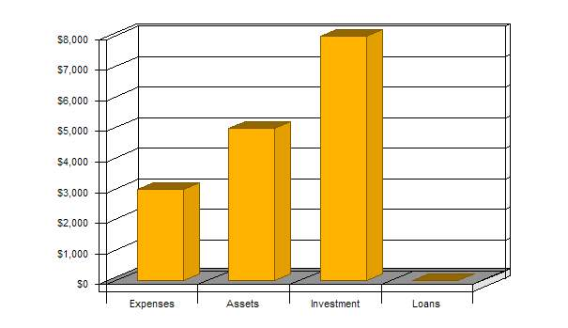
Click to Enlarge
2.3 Company Locations and Facilities | [back to top]
Initially this will be a home-based business; however, by 2005, we intend to expand our facilities into a well-equipped and operational office.
3.0 Services | [back to top]
We are a full-service wedding consultant group and provide the following services: etiquette advice, event scheduling, discounted invitations and products, vendor confirmation, rehearsal attendance, supervision of both ceremony and reception setup and budget planning.
4.0 Market Analysis Summary | [back to top]
Nearly $35 billion are spent every year on weddings and receptions. Therefore, professional wedding consultants are a commodity, not a calamity. TLC Wedding Consultants are full-service wedding consultants that offer a variety of services to our clients. We pride ourselves on being professional and courteous at all times and we have packages to suit everyone's needs.
As previously stated, marriage is a billion dollar industry, therefore, just about everyone we meet is a potential client. However, we mostly advertise to brides, grooms, and family members.
4.1 Market Segmentation | [back to top]
Although the flash and excitement of impending nuptials can be intoxicating, it can also be overwhelming. Therefore, we primarily market our services to the people who need them most--brides and grooms. In 1997, 2.4 million marriages took place in the United States. According to the Encarta Encyclopedia, the current US marriage rate of nine marriages per 1,000 people is still the highest rate among the industrialized countries. This marriage rate is expected to remain at the same level in the near future. In the Eugene, OR area where TLC Wedding Consultants plans to operate their business, over 1,500 marriages are registered each year, which creates a sizable market potential for this line of business.
Another customer segment is represented by the numerous family members and guests attending weddings, anniversaries, and similar events. This segment requires event preparation services like gift ideas, etiquette tips, etc.
Besides the wedding arrangements, which TLC Wedding Consultants believe to be their major client assignments, other events the company will provide services to include corporate retreats, etiquette training, etc. This customer segment is estimated to have the annual volume of 1,000 orders in the Eugene, OR area.
Market Analysis (Pie)
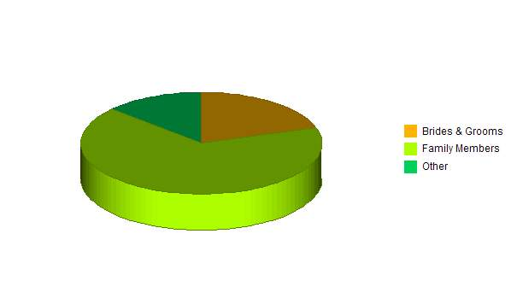
Click to Enlarge
Market Analysis
 |  | 2000 | 2001 | 2002 | 2003 | 2004
Potential Customers | Growth |  |  |  |  |  | CAGR
Brides & Grooms | 5% | 1,500 | 1,575 | 1,654 | 1,737 | 1,824 | 5.01%
Family Members | 5% | 5,000 | 5,250 | 5,513 | 5,789 | 6,078 | 5.00%
Other | 5% | 1,000 | 1,050 | 1,103 | 1,158 | 1,216 | 5.01%
Total | 5.00% | 7,500 | 7,875 | 8,270 | 8,684 | 9,118 | 5.00%

4.2 Target Market Segment Strategy | [back to top]
TLC Wedding Consultants will offer its services mostly to the brides and grooms, as well as to the family members. The company will position itself as an experienced provider of wedding planning services. Unlike most of its competitors, TLC will be offering a full range of services and thus provide the convenience of one-stop shopping for its clients. This will significantly reduce the customers' time and efforts preparing for such an important event as a wedding. Moreover, by utilizing numerous supplier contacts that the company owners have established and economies of scale, TLC Wedding Consultants will be able to pass on to its customers sizable cost savings.
4.2.1 Market Needs | [back to top]
The market needs for wedding planning services are strongly shaped by the customers' desire to have a perfectly planned and executed wedding ceremony. Although both major customer segments, brides and grooms and family members, plan and budget for the wedding ceremony as far as a year or more in advance, they often realize that they cannot make all the necessary preparations by themselves in a cost effective manner. Strongly affected by the established social values, such customers seek professional advice to ensure that all the important aspects of the wedding ceremony meet or exceed perceived expectations.
4.3 Service Business Analysis | [back to top]
The wedding services market is fragmented with the overwhelming majority of the incumbents offering only a limited line of services. There are numerous florists, hair stylists, and caterers to choose from. However, there are almost no companies that will provide the full range of services associated with the wedding planning and execution.
4.3.1 Competition and Buying Patterns | [back to top]
Competitive analysis conducted by the company owners has shown that there are 20 companies currently offering some sort of wedding planning services in the Eugene area. However, the majority of the incumbent competitors offer only a limited line of services like catering, flower arrangements or gifts. In fact, of these 25 competitors only three offered a range of services comparable with what TLC Wedding Consultants plan to offer to its customers. The following is the list of the major competitors with a brief description of their services:
- Rent-An-Action offers ceremony preparation, rehearsing and execution services.
- Cross & Reeves provide flower and catering arrangements and wedding consulting services.
- Lafayette Wedding offers its clients entertaining, catering, floral design and hair styling services.
The market research has also shown that customers anticipate the complete wedding consulting services to be expensive and they budget accordingly. In fact, lower prices are very often associated with poor service quality. By aggregating a complete range of wedding services under one roof, TLC Wedding Consultants will offer its customers the ease of one-stop shopping.
5.0 Strategy and Implementation Summary | [back to top]
Our strategy is simple: we intend to provide our customers with a wide range of services custom tailored to their individual needs. Therefore, whether they require a complete package, or simply consulting on a particular service, we can help.
5.1 Competitive Edge | [back to top]
By aggregating a complete range of wedding services under one roof, TLC Wedding Consultants will offer its customers the ease of one-stop shopping. The company will leverage its owners' expertise in planning such events to competitively position itself as a premier provider of wedding services. Both owners have very strong communication skills that will help develop the 'buzz' about the high quality of the services offered by TLC Wedding Consultants.
5.2 Sales Strategy | [back to top]
The company's sales strategy will be based on the following elements:
- Advertising in the Yellow Pages - two inch by three inch ads describing the services will be placed in the local Yellow Pages.
- Placing advertisements in the local press, including The Register Guard, Eugene Weekly, The Oregon Daily Emerald.
- Developing affiliate relationships with other service providers (florists, hair stylists, caterers) that would receive a percentage of sales to the referred customers.
- Word of mouth referrals - generating sales leads in the local community through customer referrals.
Sales Forecast
 | FY 2001 | FY 2002 | FY 2003
Sales
Brides & Grooms | $54,200 | $65,040 | $71,544
Family Members | $25,800 | $30,960 | $34,056
Other | $15,300 | $18,360 | $20,196
Total Sales | $95,300 | $114,360 | $125,796
Direct Cost of Sales | FY 2001 | FY 2002 | FY 2003
Row 1 | $0 | $0 | $0
Row 1 | $0 | $0 | $0
Other | $0 | $0 | $0
Subtotal Direct Cost of Sales | $0 | $0 | $0
Sales Monthly
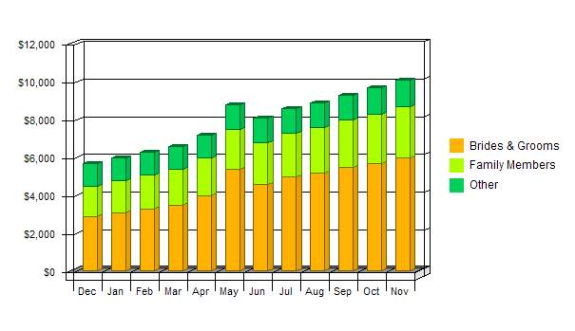
Click to Enlarge
Sales by Year
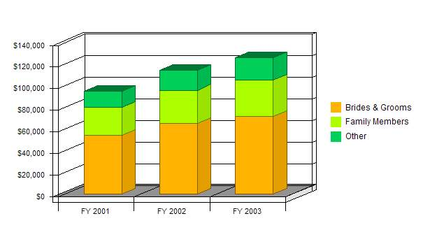
Click to Enlarge
6.0 Management Summary | [back to top]
Our wedding consultants are Darla and Micah Johnson. Collaboratively they have planned and serviced over 150 weddings and receptions. They are knowledgeable about all areas of planning, decorating, as well as budgeting. Darla has a BS in Communications and a minor in Interior Decorating. She has been a wedding consultant for five years and became interested in providing consultant services when she successfully planned her first five weddings for family and friends. Since then, Darla has received extensive training in wedding planning and her certification from the National Association of Wedding Consultants and Professional Wedding Planners. Micah has an Associates Degree in Fashion Design, and, like Darla, she became interested in becoming a consultant when she successfully planned her first three weddings. Micah received her certification from the National Association of Wedding Consultants and has been a wedding planner for three years. Micah enjoys all aspects of planning traditional and nontraditional weddings.
6.1 Personnel Plan | [back to top]
Initially, TLC Wedding Consultants' personnel will include only the two owners, both of whom will be working full time. As the personnel plan shows, we expect to hire an additional wedding consultant in the next year This person will work full time, but will not be included in the management decisions.
Personnel Plan
 | FY 2001 | FY 2002 |  | FY 2003
Owner | $53,100 | $76,200 |  | $85,800
Other | $0 | $0 |  | $0
Total People | 0 | 0 |  | 0
Total Payroll | $53,100 | $76,200 |  | $85,800
7.0 Financial Plan |  |  | [back to top]
The following subtopics represent the financial plan of TLC Wedding Consultants.
General Assumptions
 | FY 2001 | FY 2002 | FY 2003
Plan Month | 1 | 2 | 3
Current Interest Rate | 10.00% | 10.00% | 10.00%
Long-term Interest Rate | 10.00% | 10.00% | 10.00%
Tax Rate | 25.42% | 25.00% | 25.42%
Other | 0 | 0 | 0

7.1 Break-even Analysis | [back to top]
The following table and chart summarize our break-even analysis.
Break-even Analysis
Monthly Revenue Break-even | $5,468
Assumptions:
Average Percent Variable Cost | 0%
Estimated Monthly Fixed Cost | $5,468
Break-even Analysis
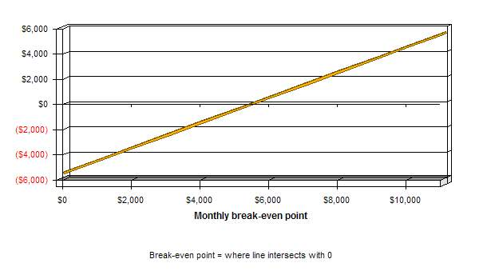
Click to Enlarge
7.2 Projected Profit and Loss | [back to top]
Our projected profit and loss is shown in the following table.
Pro Forma Profit and Loss
 | FY 2001 | FY 2002 | FY 2003
Sales | $95,300 | $114,360 | $125,796
Direct Cost of Sales | $0 | $0 | $0
Other | $0 | $0 | $0
 | ------------ | ------------ | ------------
Total Cost of Sales | $0 | $0 | $0
Gross Margin | $95,300 | $114,360 | $125,796
Gross Margin % | 100.00% | 100.00% | 100.00%
Expenses
Payroll | $53,100 | $76,200 | $85,800
Sales and Marketing and Other Expenses | $4,550 | $1,000 | $2,000
Depreciation | $0 | $0 | $0
Leased Equipment | $0 | $0 | $0
Utilities | $0 | $0 | $0
Insurance | $0 | $0 | $0
Rent | $0 | $0 | $0
Payroll Taxes | $7,965 | $11,430 | $12,870
Other | $0 | $0 | $0
 | ------------ | ------------ | ------------
Total Operating Expenses | $65,615 | $88,630 | $100,670
Profit Before Interest and Taxes | $29,685 | $25,730 | $25,126
EBITDA | $29,685 | $25,730 | $25,126
Interest Expense | $0 | $0 | $0
Taxes Incurred | $7,421 | $6,433 | $6,386
Net Profit | $22,264 | $19,298 | $18,740
Net Profit/Sales | 23.36% | 16.87% | 14.90%
Profit Monthly
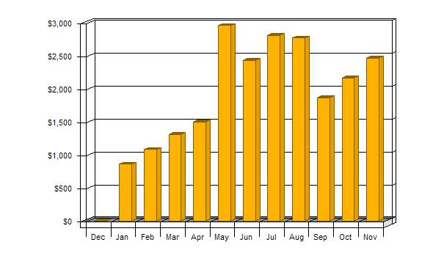
Click to Enlarge
Profit Yearly
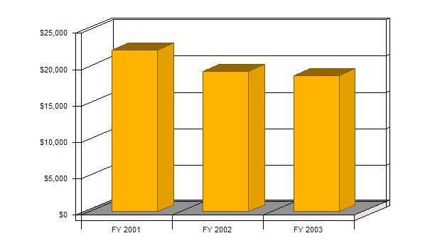
Click to Enlarge
Gross Margin Monthly
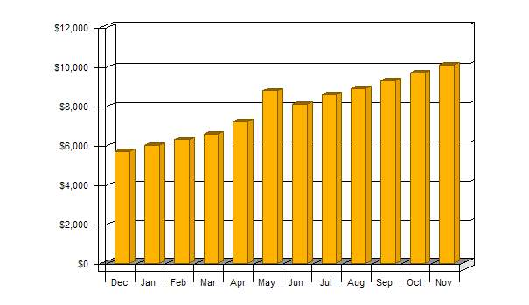
Click to Enlarge
Gross Margin Yearly
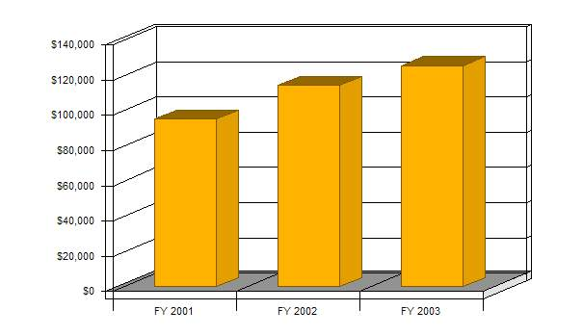
Click to Enlarge
7.3 Projected Cash Flow | [back to top]
The following chart and table show our cash flow projections.
Cash
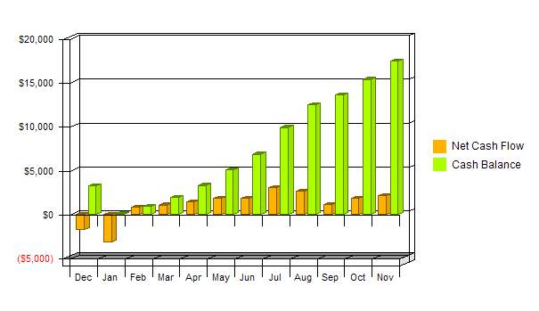
Click to Enlarge
Pro Forma Cash Flow
 | FY 2001 | FY 2002 | FY 2003
Cash Received
Cash from Operations
Cash Sales | $38,120 | $45,744 | $50,318
Cash from Receivables | $45,494 | $66,279 | $74,075
Subtotal Cash from Operations | $83,614 | $112,023 | $124,394
Additional Cash Received
Sales Tax, VAT, HST/GST Received | $0 | $0 | $0
New Current Borrowing | $0 | $0 | $0
New Other Liabilities (interest-free) | $0 | $0 | $0
New Long-term Liabilities | $0 | $0 | $0
Sales of Other Current Assets | $0 | $0 | $0
Sales of Long-term Assets | $0 | $0 | $0
New Investment Received | $0 | $0 | $0
Subtotal Cash Received | $83,614 | $112,023 | $124,394
Expenditures | FY 2001 | FY 2002 | FY 2003
Expenditures from Operations
Cash Spending | $53,100 | $76,200 | $85,800
Bill Payments | $18,072 | $19,177 | $21,059
Subtotal Spent on Operations | $71,172 | $95,377 | $106,859
Additional Cash Spent
Sales Tax, VAT, HST/GST Paid Out | $0 | $0 | $0
Principal Repayment of Current Borrowing | $0 | $0 | $0
Other Liabilities Principal Repayment | $0 | $0 | $0
Long-term Liabilities Principal Repayment | $0 | $0 | $0
Purchase Other Current Assets | $0 | $0 | $0
Purchase Long-term Assets | $0 | $0 | $0
Dividends | $0 | $0 | $0
Subtotal Cash Spent | $71,172 | $95,377 | $106,859
Net Cash Flow | $12,442 | $16,646 | $17,534
Cash Balance | $17,442 | $34,088 | $51,623

7.4 Projected Balance Sheet | [back to top]
Three years of annual totals are presented in the Projected Balance Sheet below. First year monthly figures are included in the appendix.
Pro Forma Balance Sheet
 | FY 2001 | FY 2002 | FY 2003
Assets
Current Assets
Cash | $17,442 | $34,088 | $51,623
Accounts Receivable | $11,686 | $14,023 | $15,426
Other Current Assets | $0 | $0 | $0
Total Current Assets | $29,128 | $48,112 | $67,048
Long-term Assets
Long-term Assets | $0 | $0 | $0
Accumulated Depreciation | $0 | $0 | $0
Total Long-term Assets | $0 | $0 | $0
Total Assets | $29,128 | $48,112 | $67,048
Liabilities and Capital | FY 2001 | FY 2002 | FY 2003
Current Liabilities
Accounts Payable | $1,864 | $1,550 | $1,747
Current Borrowing | $0 | $0 | $0
Other Current Liabilities | $0 | $0 | $0
Subtotal Current Liabilities | $1,864 | $1,550 | $1,747
Long-term Liabilities | $0 | $0 | $0
Total Liabilities | $1,864 | $1,550 | $1,747
Paid-in Capital | $8,000 | $8,000 | $8,000
Retained Earnings | ($3,000) | $19,264 | $38,561
Earnings | $22,264 | $19,298 | $18,740
Total Capital | $27,264 | $46,561 | $65,301
Total Liabilities and Capital | $29,128 | $48,112 | $67,048
Net Worth | $27,264 | $46,561 | $65,301

7.5 Business Ratios | [back to top]
The following table outlines some of the more important ratios from the Personal Services industry. The final column, Industry Profile, details specific ratios based on the industry as it is classified by the Standard Industry Classification (SIC) code, 7299.
Ratio Analysis
 | FY 2001 | FY 2002 | FY 2003 | Industry Profile
Sales Growth | 0.00% | 20.00% | 10.00% | 17.90%
Percent of Total Assets
Accounts Receivable | 40.12% | 29.15% | 23.01% | 11.10%
Other Current Assets | 0.00% | 0.00% | 0.00% | 37.10%
Total Current Assets | 100.00% | 100.00% | 100.00% | 52.80%
Long-term Assets | 0.00% | 0.00% | 0.00% | 47.20%
Total Assets | 100.00% | 100.00% | 100.00% | 100.00%
Current Liabilities | 6.40% | 3.22% | 2.61% | 33.90%
Long-term Liabilities | 0.00% | 0.00% | 0.00% | 28.00%
Total Liabilities | 6.40% | 3.22% | 2.61% | 61.90%
Net Worth | 93.60% | 96.78% | 97.39% | 38.10%
Percent of Sales
Sales | 100.00% | 100.00% | 100.00% | 100.00%
Gross Margin | 100.00% | 100.00% | 100.00% | 0.00%
Selling, General & Administrative Expenses | 70.37% | 75.63% | 77.35% | 72.70%
Advertising Expenses | 3.52% | 0.87% | 1.59% | 2.20%
Profit Before Interest and Taxes | 31.15% | 22.50% | 19.97% | 4.00%
Main Ratios
Current | 15.62 | 31.03 | 38.38 | 1.81
Quick | 15.62 | 31.03 | 38.38 | 1.33
Total Debt to Total Assets | 6.40% | 3.22% | 2.61% | 61.90%
Pre-tax Return on Net Worth | 108.88% | 55.26% | 38.48% | 6.30%
Pre-tax Return on Assets | 101.91% | 53.48% | 37.47% | 16.60%
Additional Ratios | FY 2001 | FY 2002 | FY 2003
Net Profit Margin | 23.36% | 16.87% | 14.90% | n.a
Return on Equity | 81.66% | 41.45% | 28.70% | n.a
Activity Ratios
Accounts Receivable Turnover | 4.89 | 4.89 | 4.89 | n.a
Collection Days | 57 | 68 | 71 | n.a
Accounts Payable Turnover | 10.69 | 12.17 | 12.17 | n.a
Payment Days | 27 | 33 | 28 | n.a
Total Asset Turnover | 3.27 | 2.38 | 1.88 | n.a
Debt Ratios
Debt to Net Worth | 0.07 | 0.03 | 0.03 | n.a
Current Liab. to Liab. | 1.00 | 1.00 | 1.00 | n.a
Liquidity Ratios
Net Working Capital | $27,264 | $46,561 | $65,301 | n.a
Interest Coverage | 0.00 | 0.00 | 0.00 | n.a
Additional Ratios
Assets to Sales | 0.31 | 0.42 | 0.53 | n.a
Current Debt/Total Assets | 6% | 3% | 3% | n.a
Acid Test | 9.36 | 21.99 | 29.55 | n.a
Sales/Net Worth | 3.50 | 2.46 | 1.93 | n.a
Dividend Payout | 0.00 | 0.00 | 0.00 | n.a

