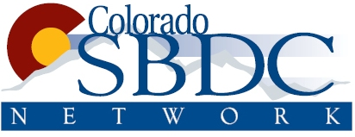

Google and Colorado SBDC invite you to get your business online…for free!

If you don’t have a website or online business listing, you’ll find everything you need to get started – web professionals at your side every step of the way. If your business is already online, you’ll find tools and resources to help you succeed. Space is limited, so register in advance for this FREE event.


 | Build your free website 1.5 hours  Create and publish a website for your business using Intuit Sitebuilder. We’ll provide laptops or a place to plug-in if you bring your own.  • Set up your free website account.  • Register a domain name (your “address” on the web).  • Select a website template and learn how to customize it.  • Publish your website.
 | Grow your business online 1 hour  • Learn the basics of how other people find your business online, with methods like search engine optimization (SEO), web analytics and more.  • Run your business more efficiently with online tools, including applications for improving collaboration and communication.
 | Promote your business online 1 hour  • Attract customers down the street or across the country with online marketing tools like Google AdWords and AdWords Express.  • Learn how to focus your marketing efforts and budget for your target audience.
 | Online Expo All day  No pre-registration is needed to participate in the Online Expo. Sit down with Google team members to get one-on-one advice. Be sure to bring your toughest online marketing questions!

Colorado Get Your Business Online in Denver

Please register now, spots will fill up quick!



Monday May 14th
7:30am – 5:30pm

Tuesday, May 15th
7:30am – 2:00pm

The Cable Center
2000 Butchel Boulevard
Denver, Co 80210
Get Directions

