Description:
The Pikes Peak region and businesses across the nation have, without a doubt, been greatly impacted by mandatory closures and stay at home orders. The SBDC has experience working 3 past disasters and know that cash is king. Our panel includes the latest local and national funding sources to help your businesses including:
-El Paso County Economic Development (Enterprise Zone Grant Fund)
-El Pomar (Non-Profit Grants)
-Exponential Impact (Survive&Thrive loans)
-Small Business Administration (EIDL Advanced Loans, Paycheck Protection Program and other CARES Act details)
If you need help now, get help from the small business experts at the SBDC and request free consulting at www.pikespeaksbdc.org/consulting get all the small business Covid-19 updates at www.pikespeaksbdc.org/prepare

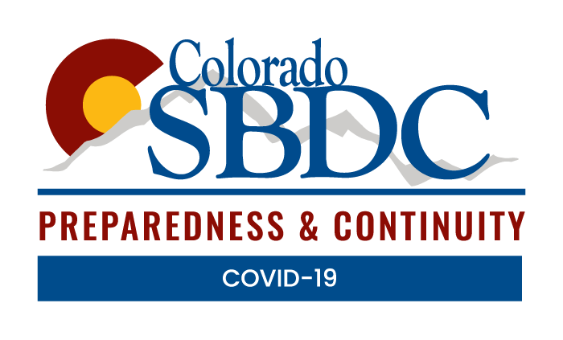

About the TechSource: Cyber CYA Program:
This workshop is part of our Colorado SBDC Preparedness & Continuity program, consisting of workshops, resources, and free consulting to help businesses cover their digital assets. Find other cybersecurity workshops and webinars here.

Sponsored by:


Registration closes 24 hours prior to the event.

