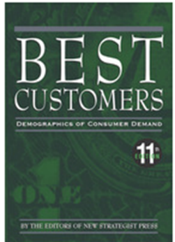
www.poudrelibraries.org

- Research – Demographics Now

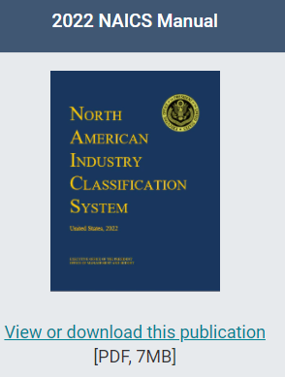
www.poudrelibraries.org

- Research


https://coloradobusinessresourcebook.com/
(English and Spanish versions)


https://oedit.colorado.gov




www.larimersbdc.org



www.score.org

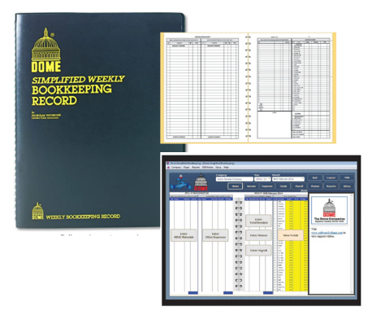
https://thedomecompanies.com

