REFERANCE MATERIALS
BUSINESS PLAN 201
LARIMER SMALL BUSINESS DEVELOPMENT CENTER (SBDC)
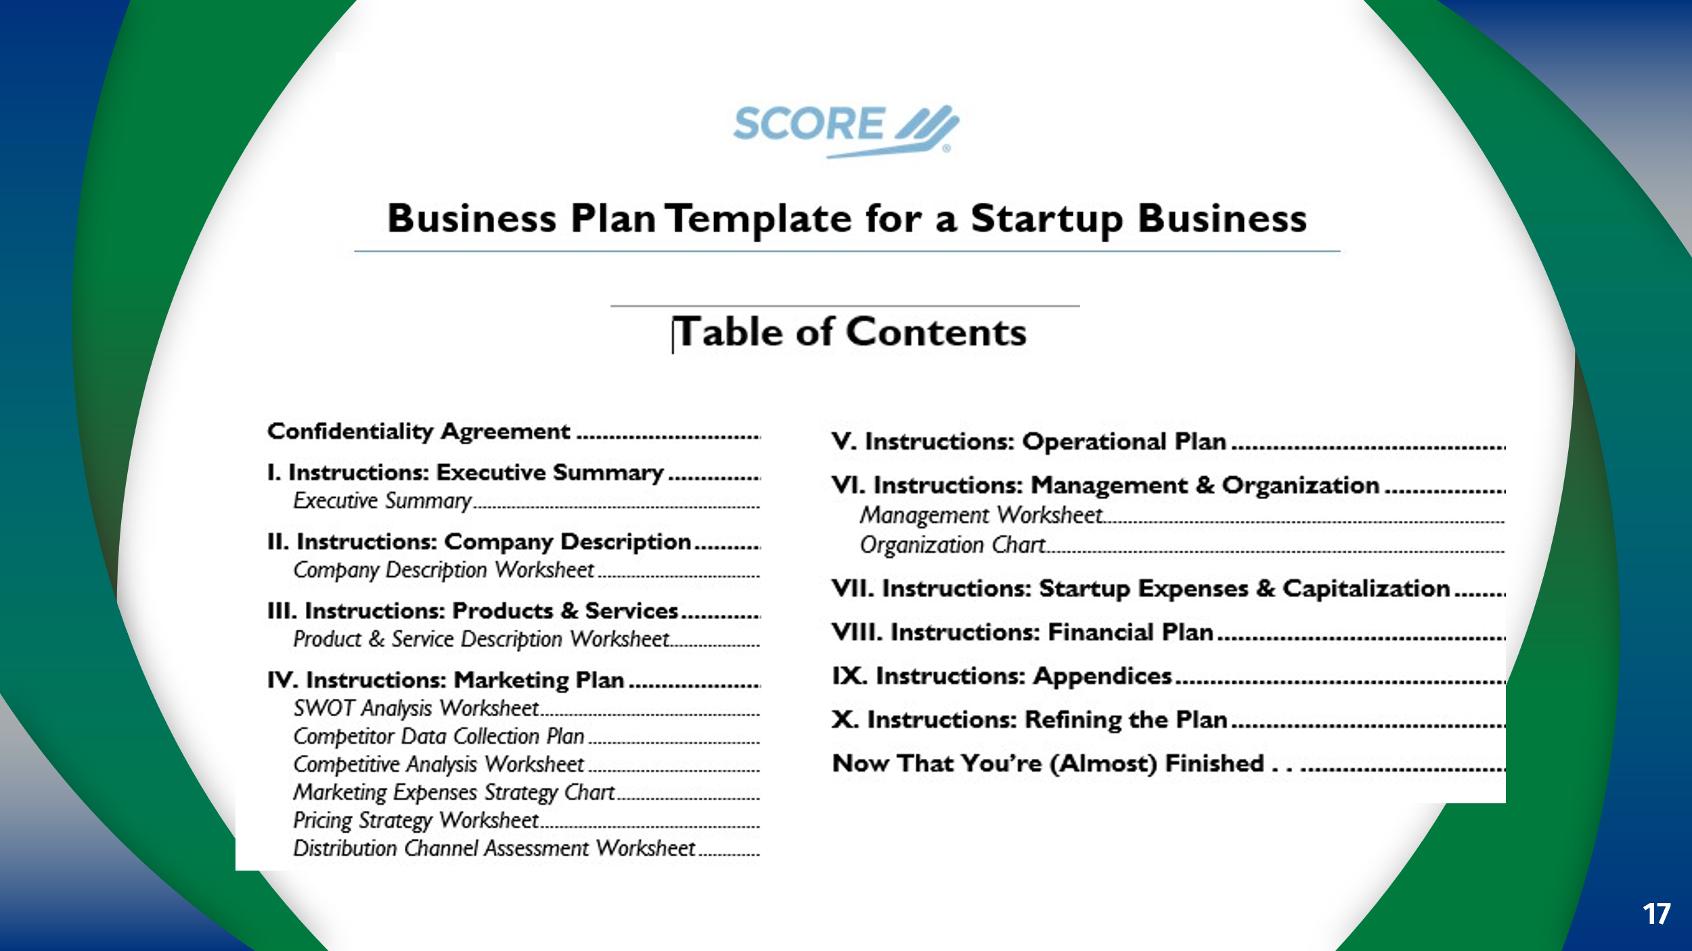
Includes Annual Marketing Budget Template: Sales Forecast spreadsheet; Job Analysis Worksheet; Start-Up Expenses template; Opening Day Balance Sheet; Balance Sheet ; Projected; 12-Month Profit and Loss Projection; 3-Year Profit and Loss Projection; 12-Month Cash Flow Statement; 3-Year Cash Flow Statement; Break Even Analysis Template; RMA Book
https://www.score.org/resource/template/business-plan-template-a-startup-business
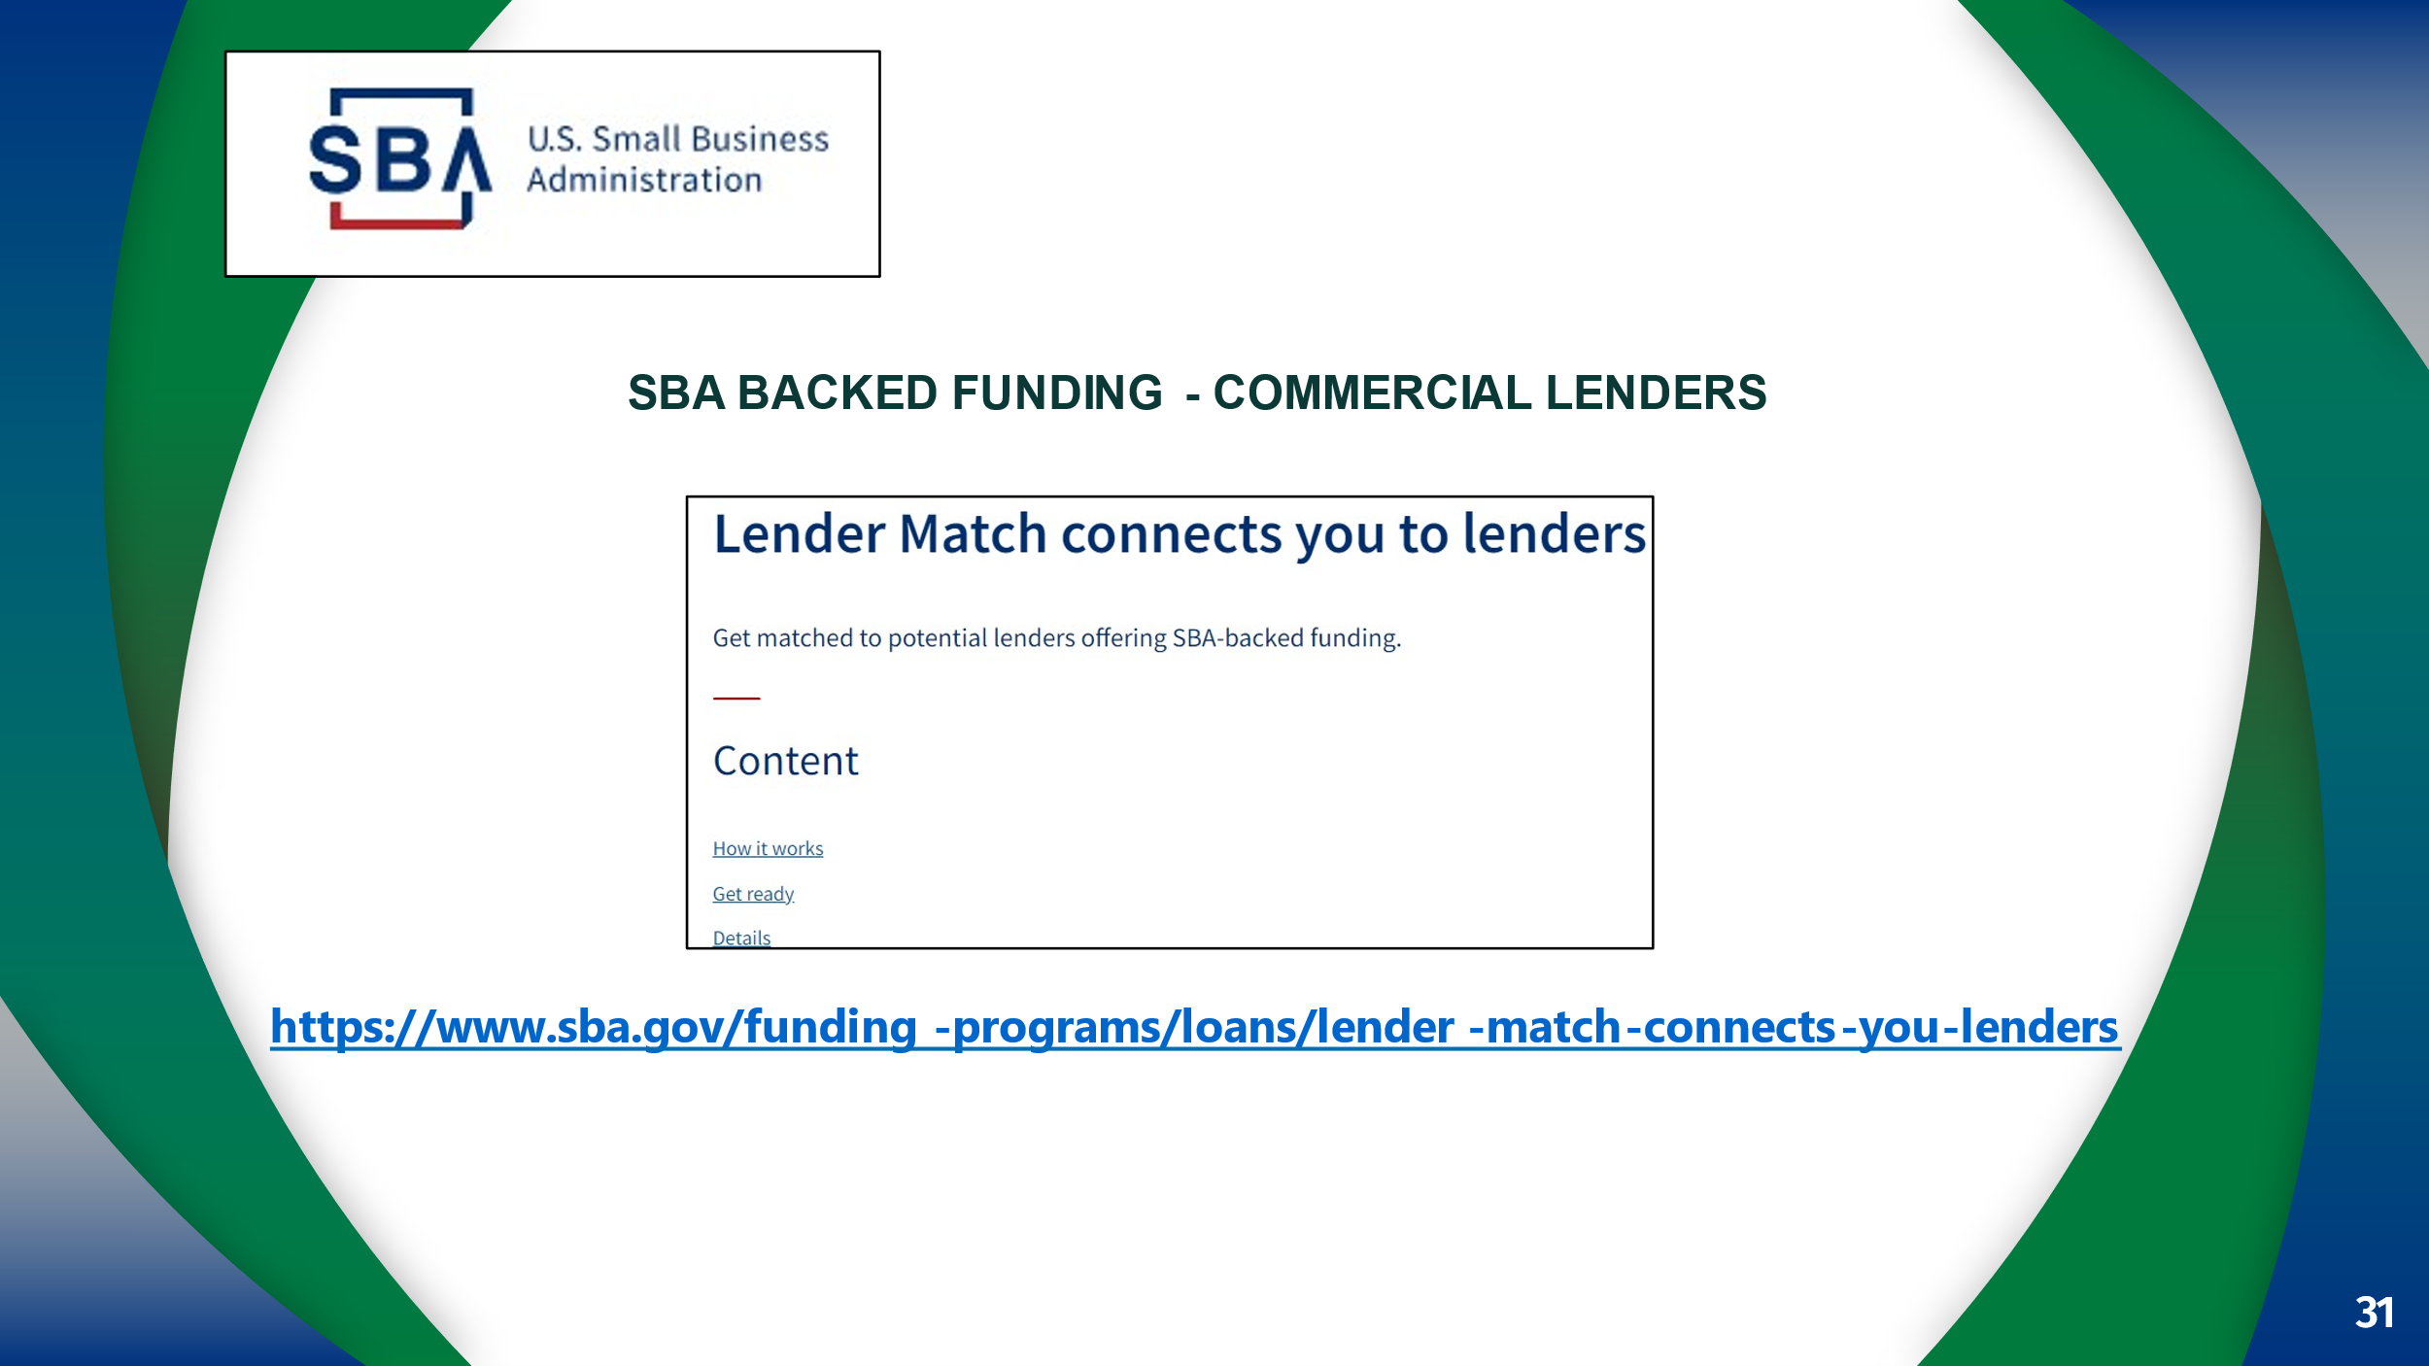
Lender Match connects you to lenders | U.S. Small Business Administration (sba.gov)
Community and Micro-Lenders
https://www.sba.gov/funding-programs/loans/microloans/list-microlenders

Equity Investors

https://oedit.colorado.gov/venture-capital-authority

https://angelmatch.io/investors/by-location/colorado

https://startupcolorado.org/resource-center/funding-database

Grants

https://www.grantwatch.com

https://grants.gov

https://www.sbir.gov

Resources
Amada Simental
Business & Nonprofit Librarian
970-818-8035
asimental@poudrelibraries.org

https://coloradobusinessresourcebook.com/
W
https://www.larimersbdc.org

